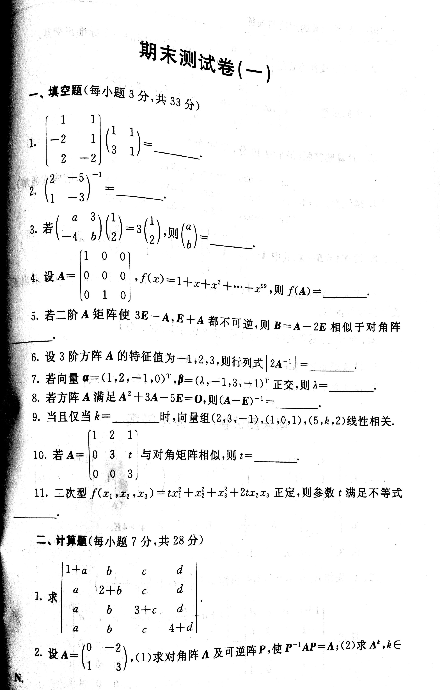

由 扫描全能王 扫描创建

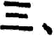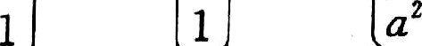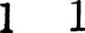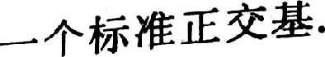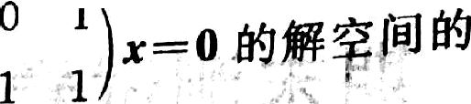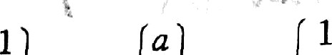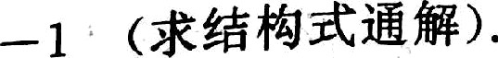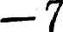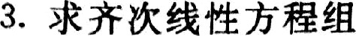

 



& . ñ$Œ/H&B‹M ı g¡ s I,g 2 & s 9„••. 9 p›

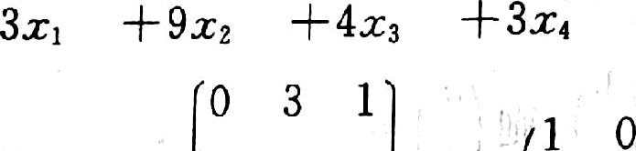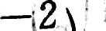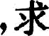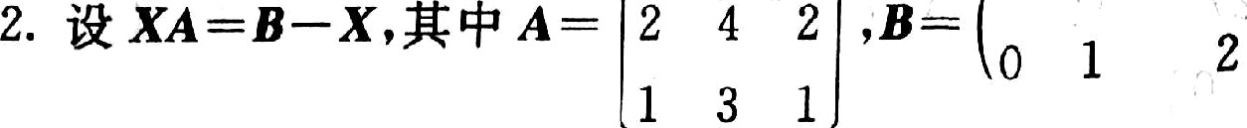

0

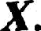

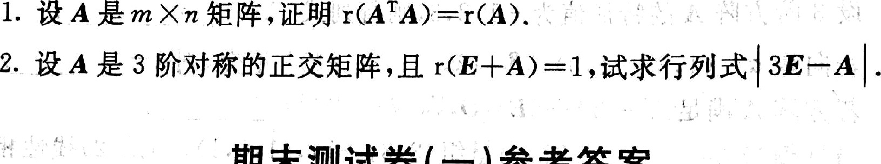

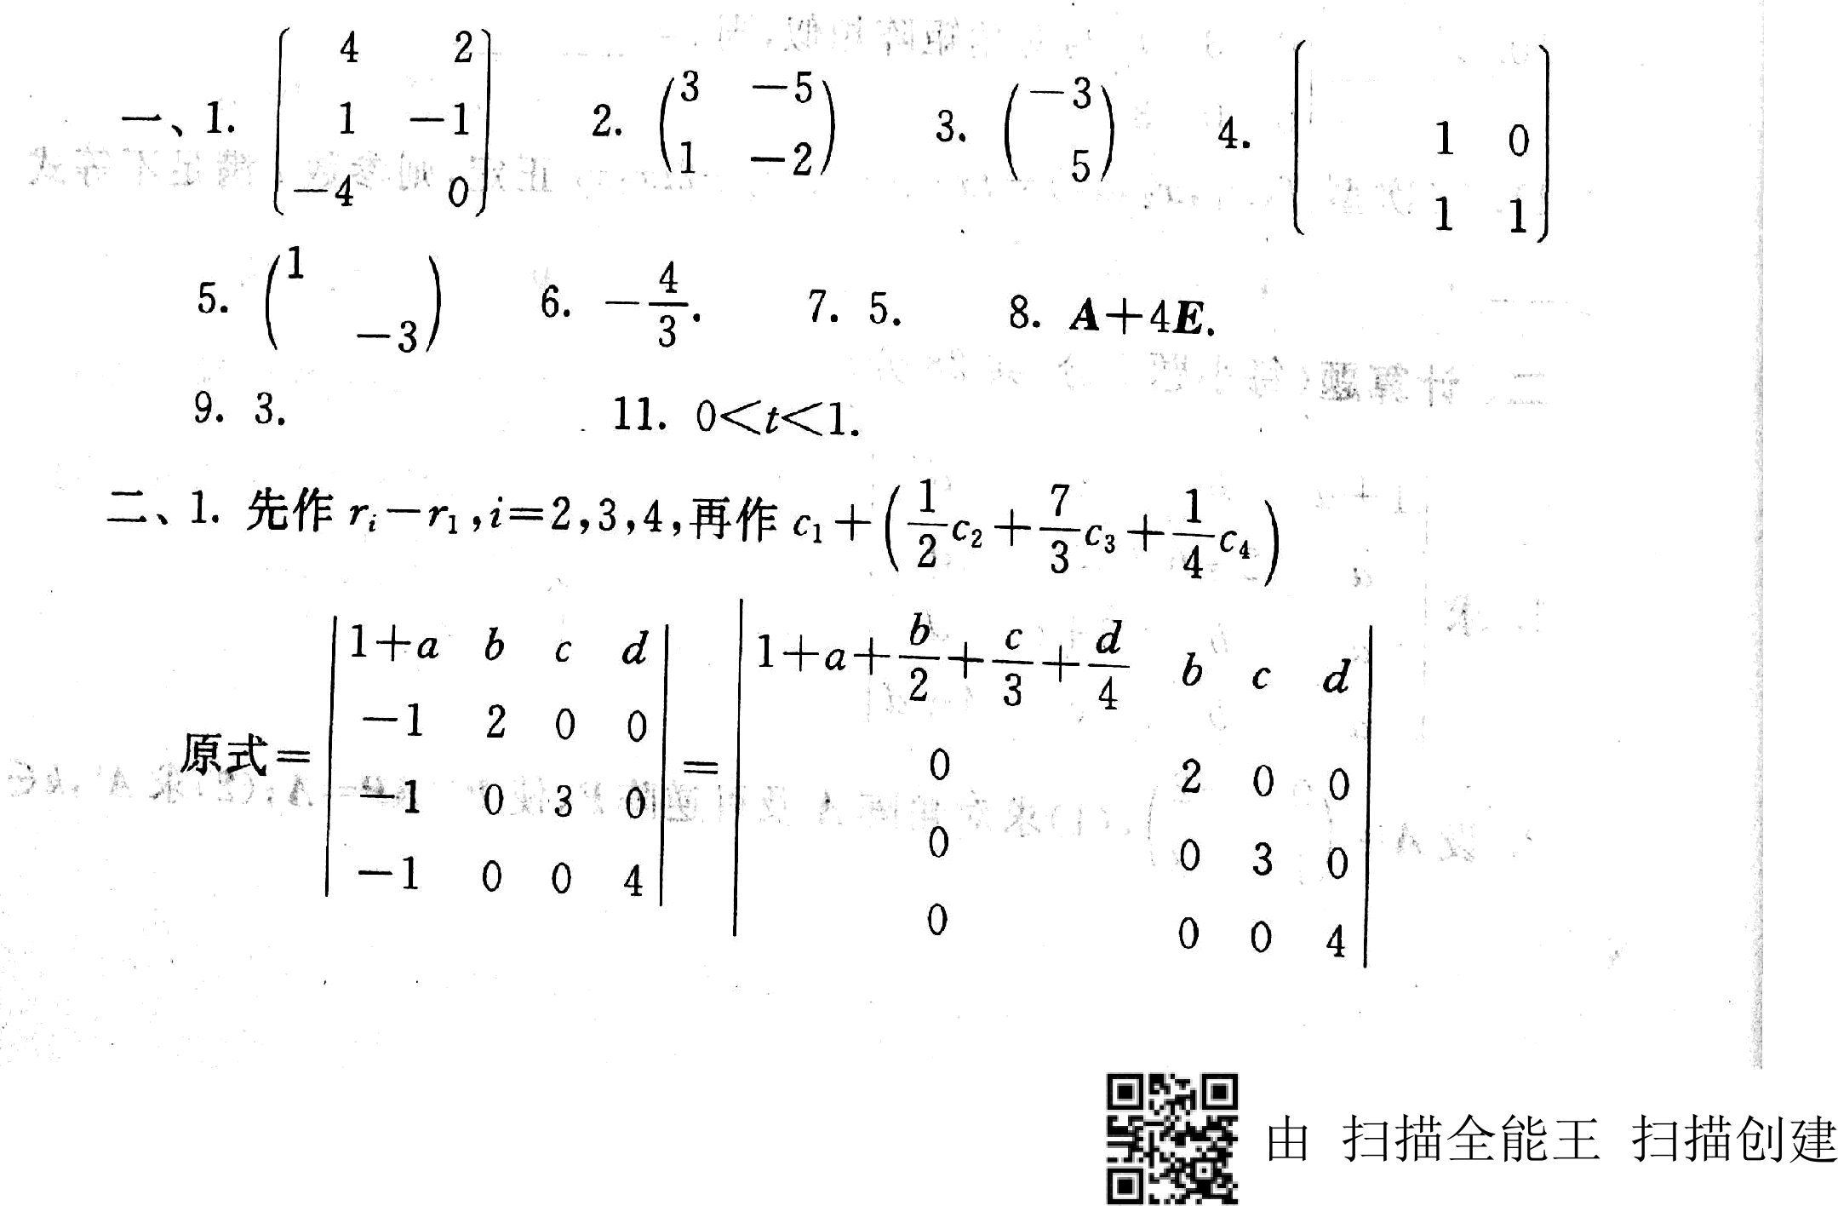

100'

10. 0.

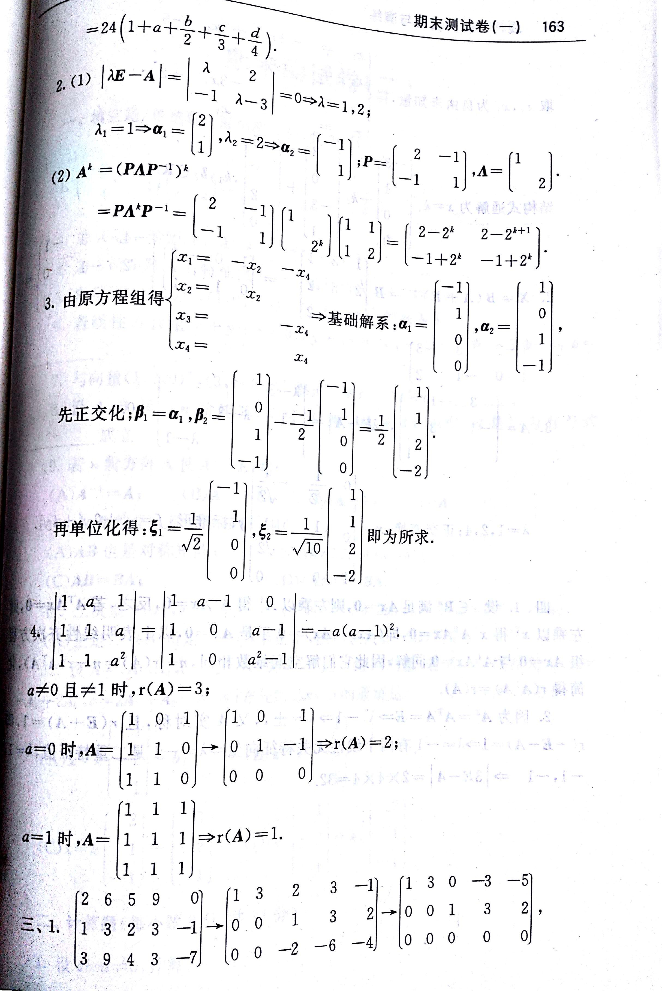

由 扫描全能王 扫描创建



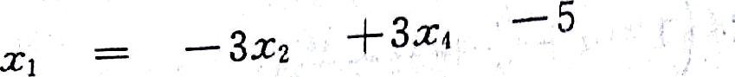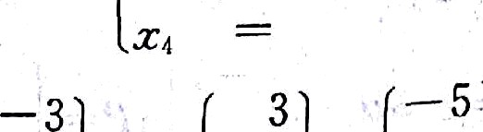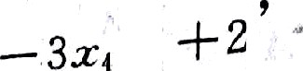

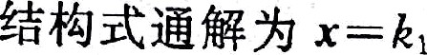 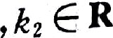

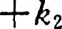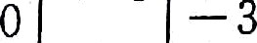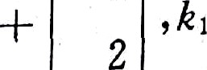

0

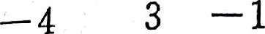

|  |  |  |  |  |
| --- | --- | --- | --- | --- |
|  | 1 |  |  | 0 |
| 0 |  |  | l |
| 2. X — *B* (A --J- £')" | *B* | 2 | 5 | 2 |
|  |  | 1 | 3 | 2 |

1 0 —!

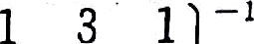

|  |  |  |
| --- | --- | --- |
| z | — ı | o = |
| — 1 | 0 | , 1 |

0 1 z

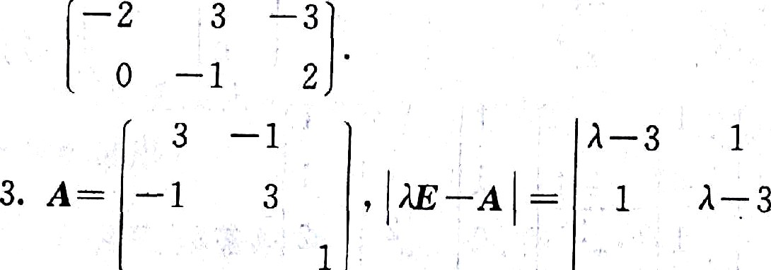 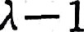

0

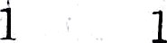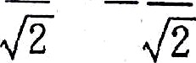

-0.

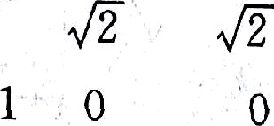



‹ *« a«a» ‹•e

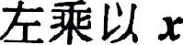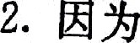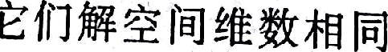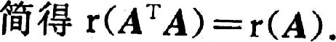

T • T T

*

•••

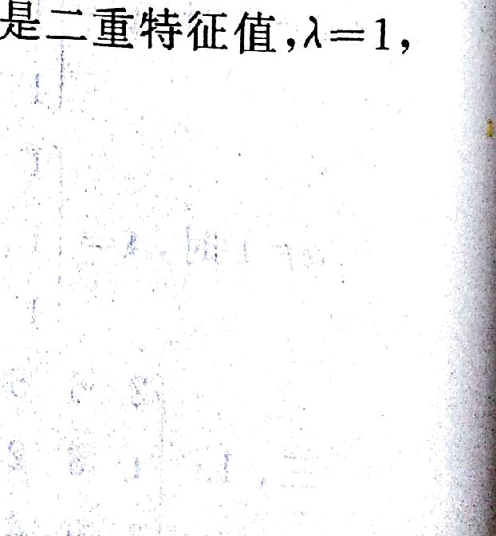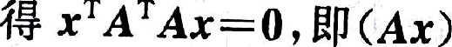

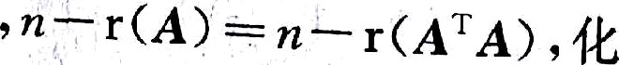

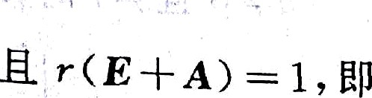

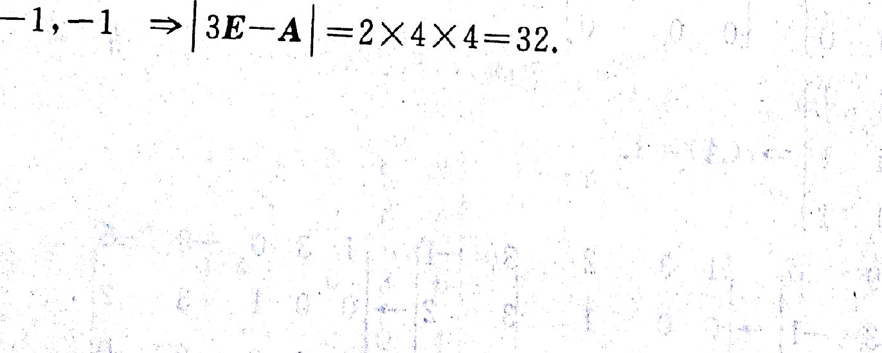

r( *—E — A* —



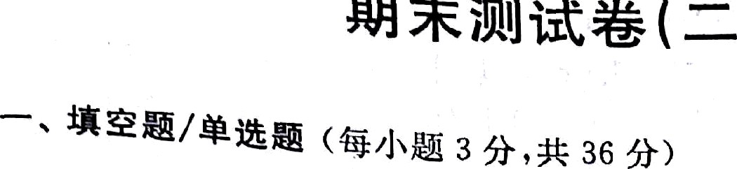

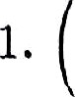 2

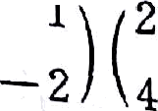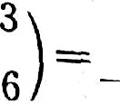

 2.

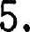

2 "

3 —~~—~~

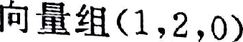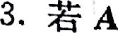





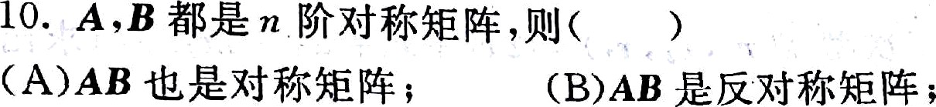

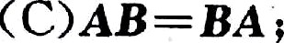 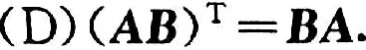

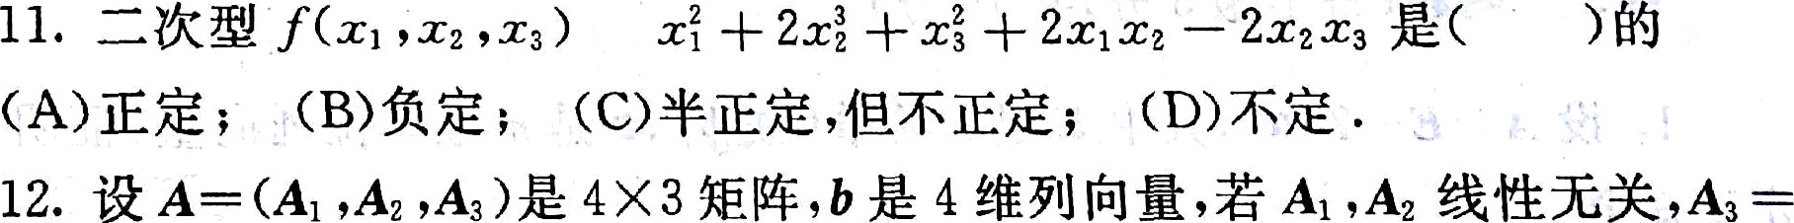

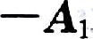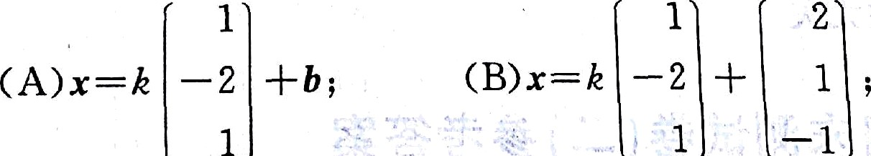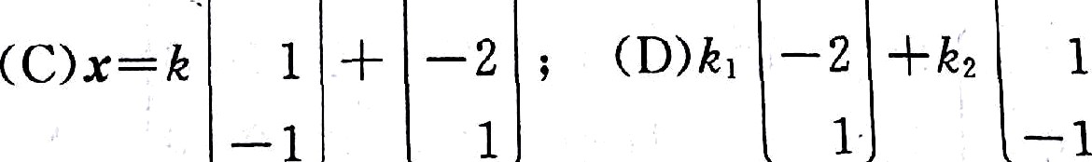

g

1

1

2

##### x. iłSa «ørJ'õ a 9.4í 2s 9s

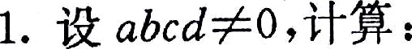







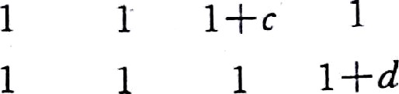

I *a* — 3 3

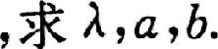



— 2 3 1 ’0

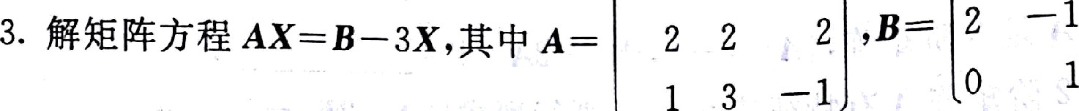

ü. îł#Räa«›*J* a ›o £›,•*. 3o U›

## › • żıo‹t•t. T›«łtäa‹x«s› zïs‹t«nAî»«sı •

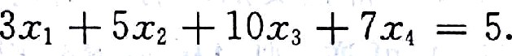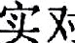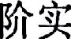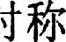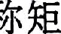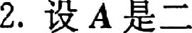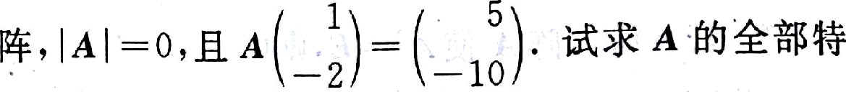



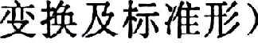







ìI % Ø›.Ø›.Ø3Q%tXK.

3 8. . 4. —8. 5.2. 6. —2.

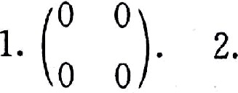





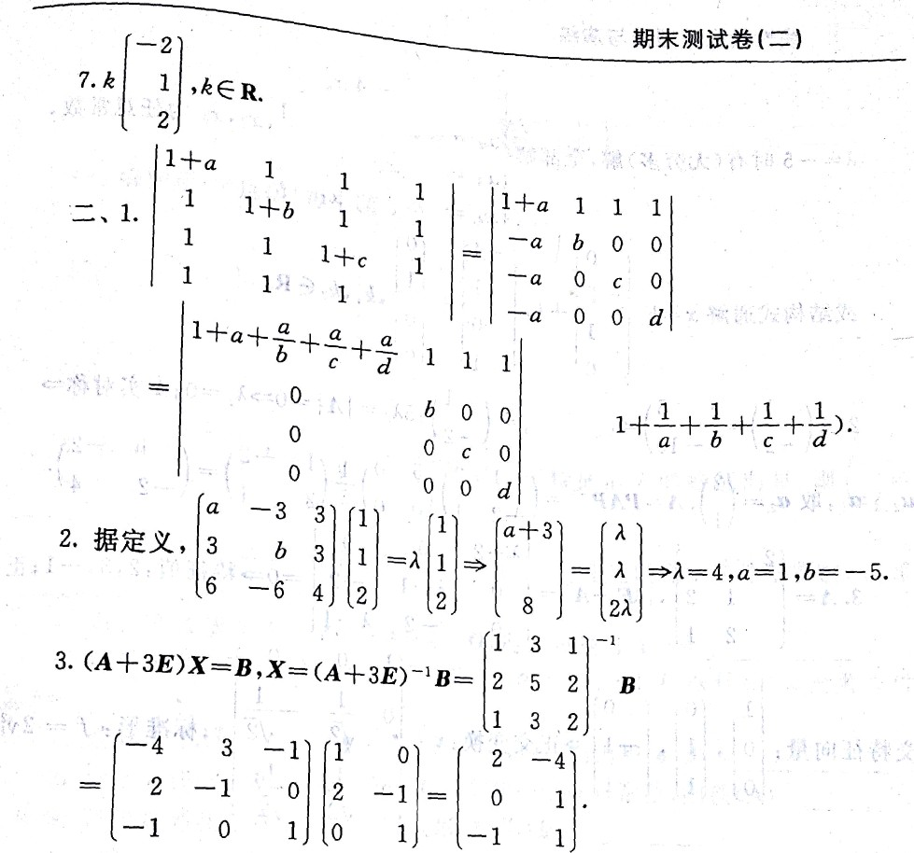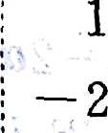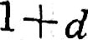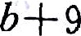

167

" ‘”"**°=øa•

• A. IØ. D. 11. C. 12. B.

*—— abcd(*

1 3

1 . ł

0 0

1

3 1

1 3 2 0 0 1

0

0 1 . — 1

0

1

o

0

o ı

### ı ı z s ı ı o o ' o

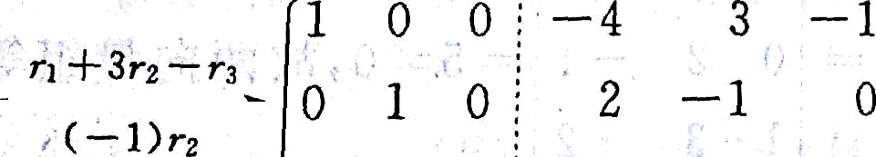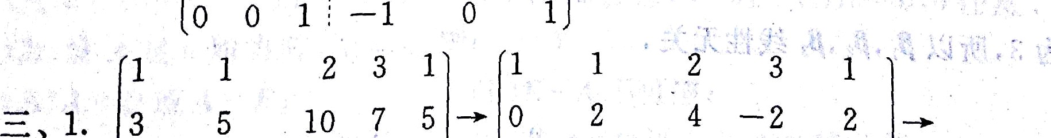

ı

—s

— lo 9 ı

*

—6

— ız

s

*— ı



0 1 2 — ı 1 --• 0 1 2 —1 1

0 0 0 0 -¡- ç 0 0 0 0 â -ł-5







*‹—"

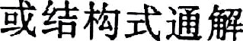

|  |  |  |
| --- | --- | --- |
| 0 | -4 | 0 |
|  | 0 | 0 |
| 0 | 1 | 0 |

2.A 1 —

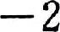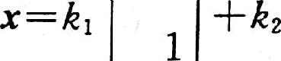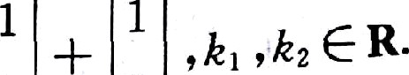

5 1

ı2,=5,m,= 

—2 —10 —2

o›1o, .:g o, - ı . *=e›ıe—' = 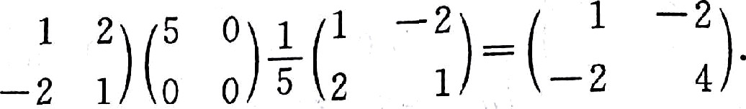*

2 2-2 O 0

5.A- 1 2 ,l —AI= O 1—1 —2 == O ¢ ,2,3,— 1;

2 1 o —2 A—1

l 0 0

1 0 0

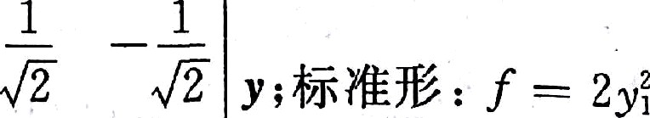

0

# zxx« : o . 1 . —1 »zzzx:•-

0 1 1 1 I

0

—

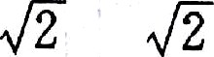

1 0 1

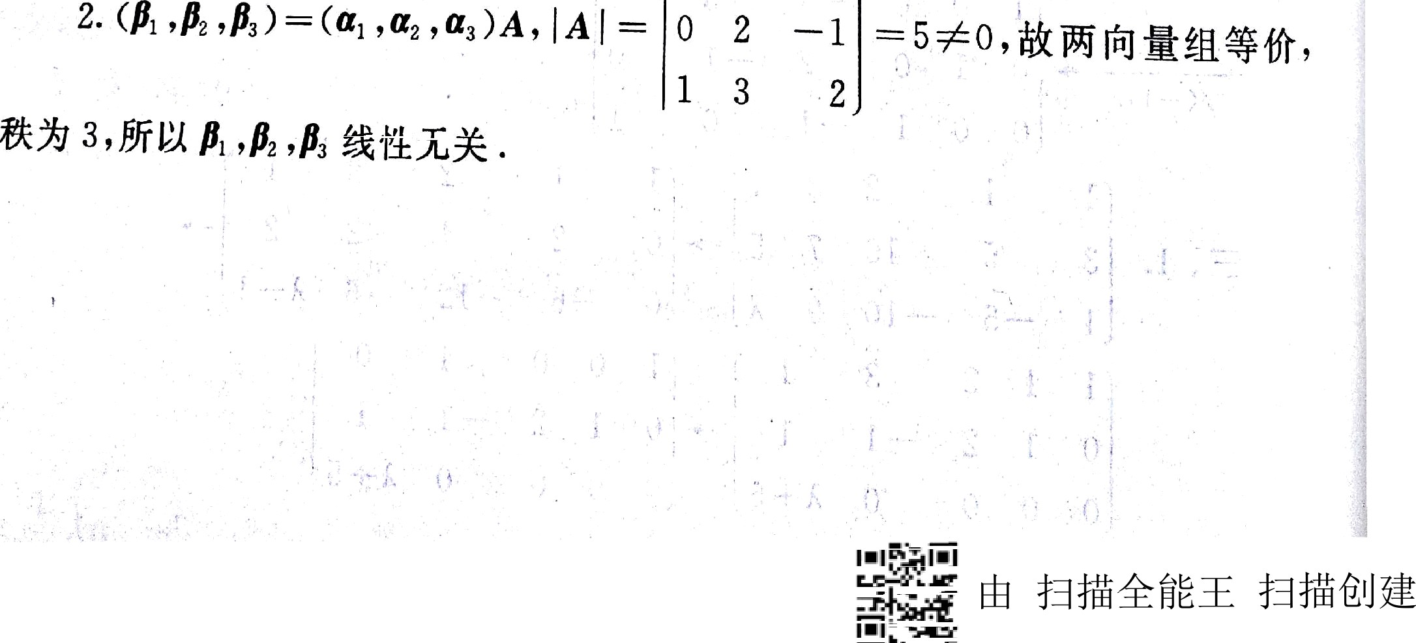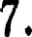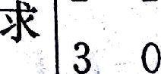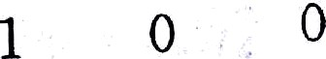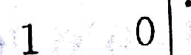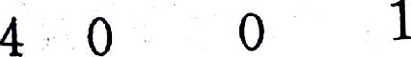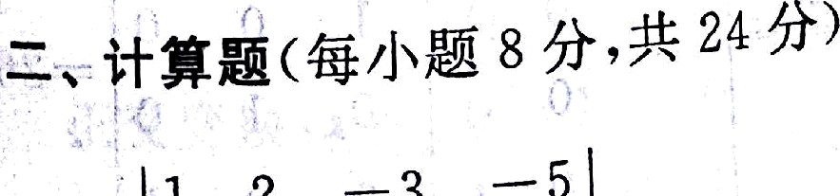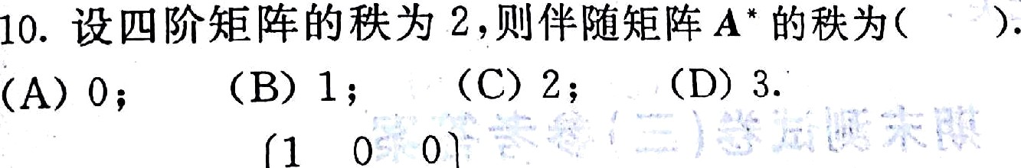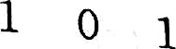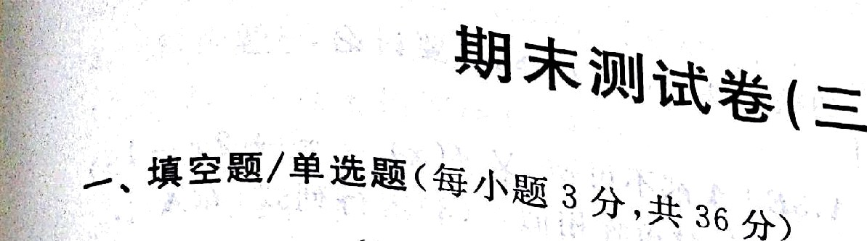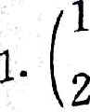

—2

1

o*

0

2

2

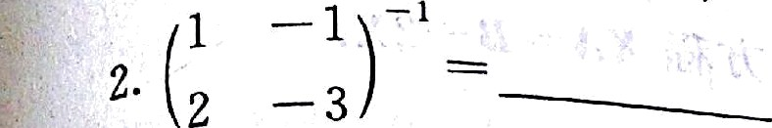

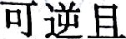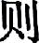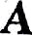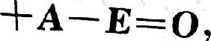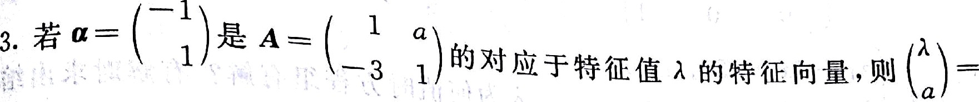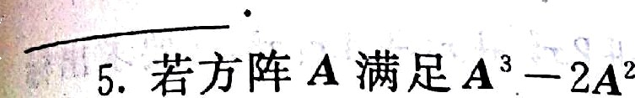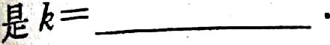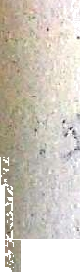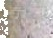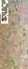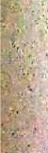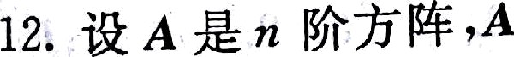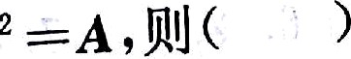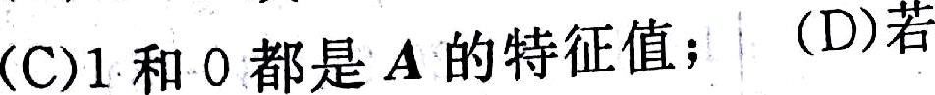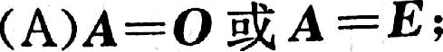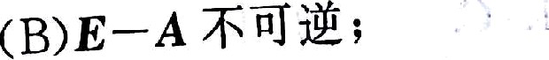

8. śt 3 xîñ &żra?A x•—a

. =•. .

axo ›ø!J 1jś A głYÑtłî -



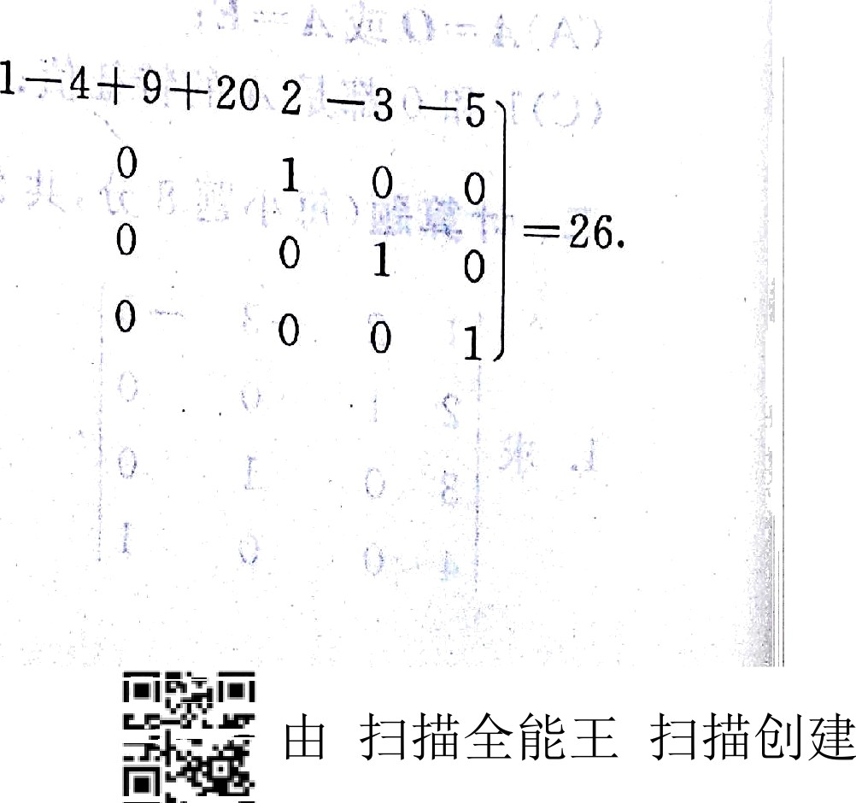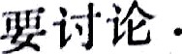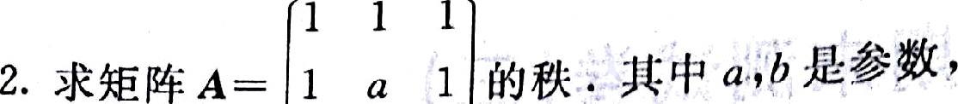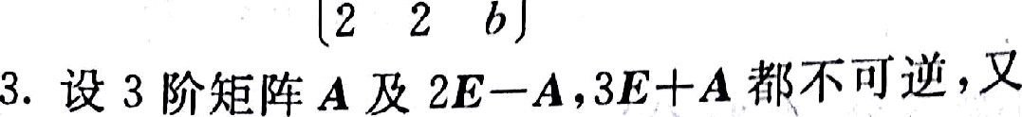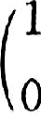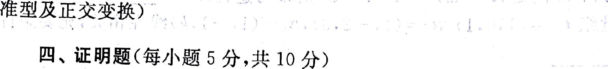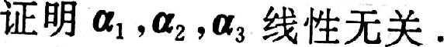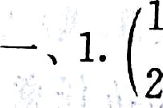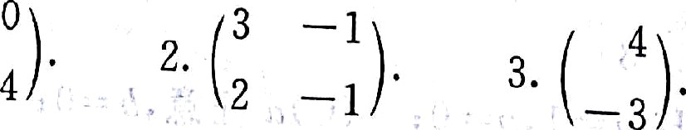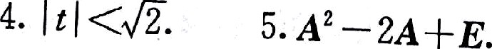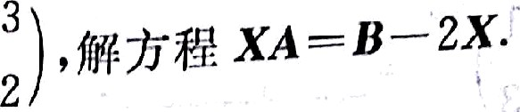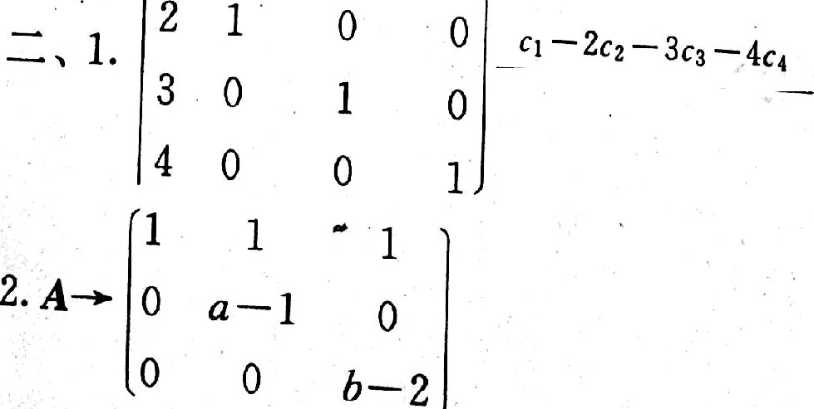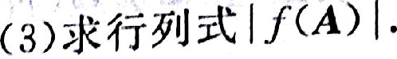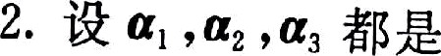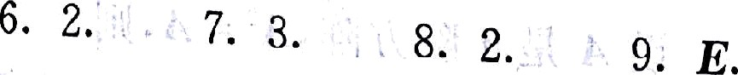



*f ‹ x)* -*' * zr — ı .



— 1 2 0

0

1. A - 0 — 1 — 3 , f ł -



0 0 — 1

## zzn«øag6>„ łTta g .

• -+ ãs.•..•. «k,x x.«3 x ,«, ,«, øı-g «, ;ç„

îk:*1ïùż”& ( «») &-, ,ä

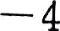

2

İO. A. 11. C. 12. D.

1 2 , 3 —5

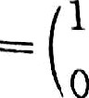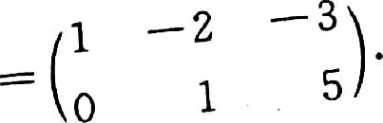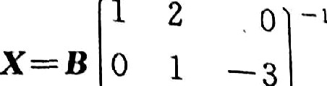

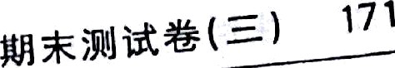

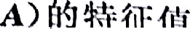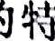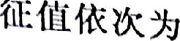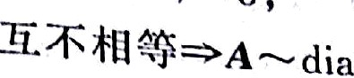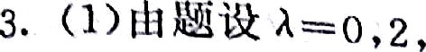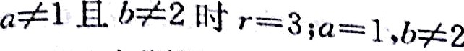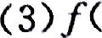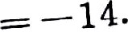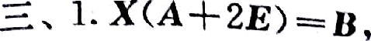

(2)0,2,-3

afO ,2,-a);

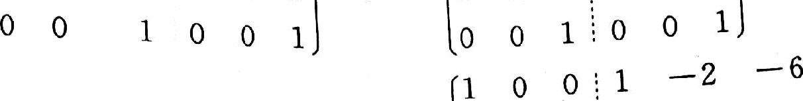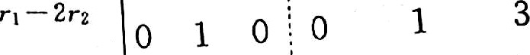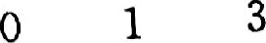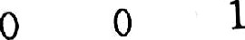

1 —2 -6

0

0 0

;

2*

o o 1

D

g

1

|  |  |  |  |  |  |  |  |  |  |  |  |
| --- | --- | --- | --- | --- | --- | --- | --- | --- | --- | --- | --- |
| 1 | 4 | 2 | 3 | l | ı | 4 | 2 | 3 | 1 | 0 -10 -l3 | |
| 1 | 5 | 5 | 7 | à | 0 | 1 | 3 | 4 à— ı | o | o | o o |



4

10 13 —8

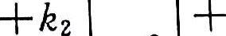

ż— 2

—3 —4

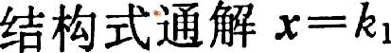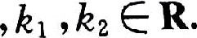

0



1 0

2

1

0

— 1

— 0 — —

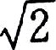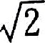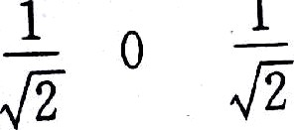



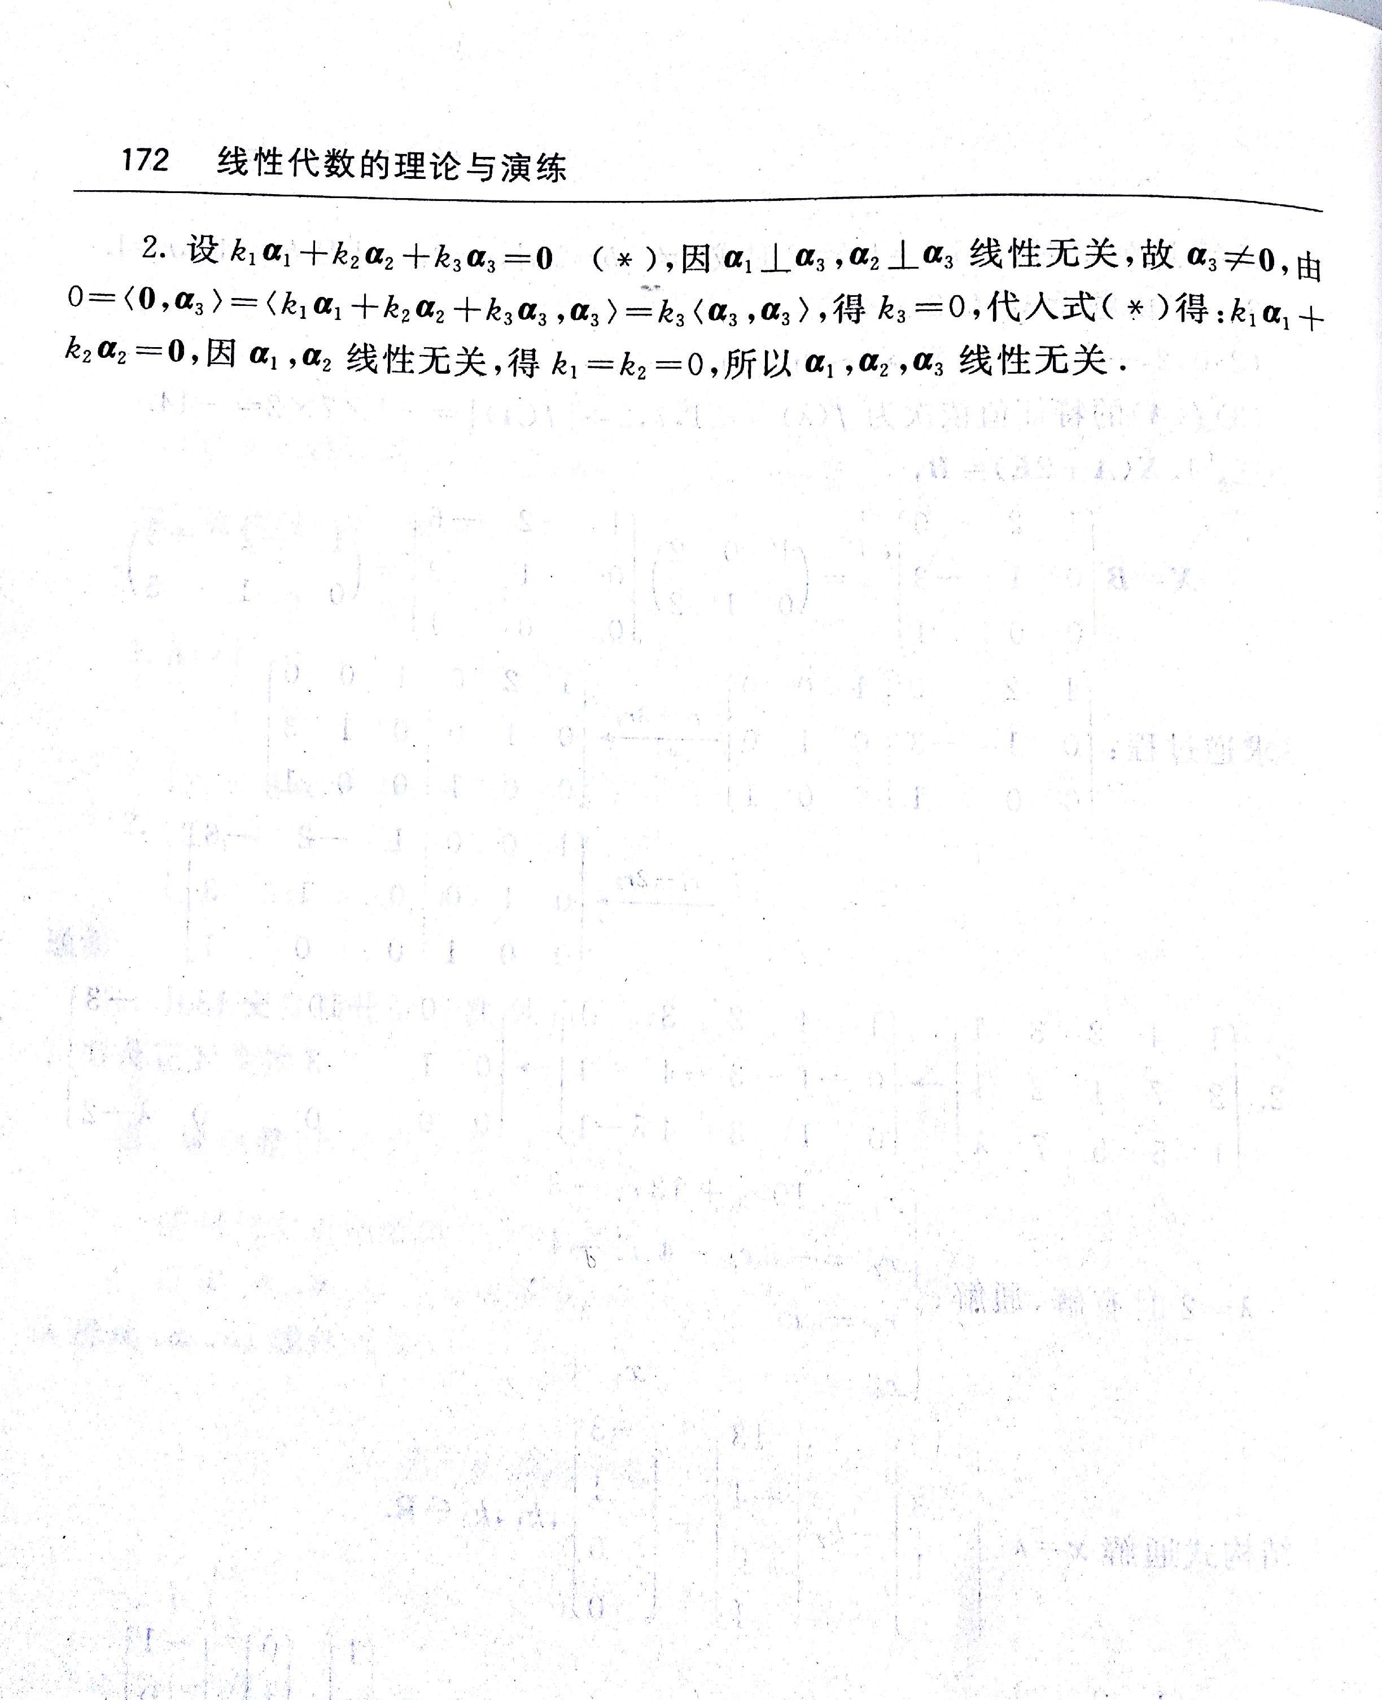

由 扫描全能王 扫描创建

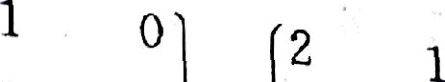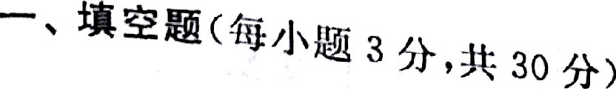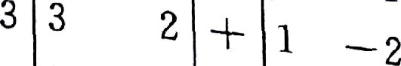

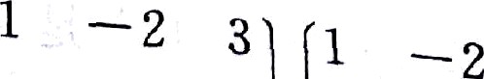

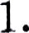

2. 2 g 2 _

' ' 0 2 ”

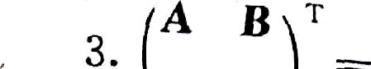

-2 4

4.

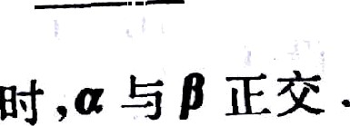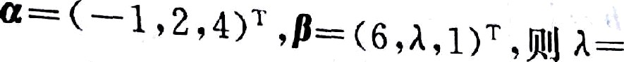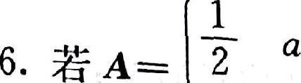

—2 3

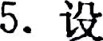

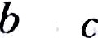

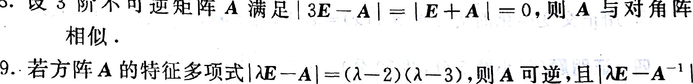



2Aı *—A•* —J— 1A• • ŚÎÁ‘ŁJ?B?& A*=6 &?&& & ‹—



|  |  |  |  |
| --- | --- | --- | --- |
| ì  z | 0  s | 0  t | —2  — z |
| —5 | 2 | 6 | 7 |
| —4 | 0 | 1 | 5 |

2. ;Q J;jg¡¡q G : of =‹ı, o, —to’ ,e, — ‹3,a, —is , n,-¡s,¢ , — J .

###### ‹1s¿ìñ :R,& G gj;ç , ‹2 :í:-5 G Á6tg —*ć t'v&EZñ E9t .

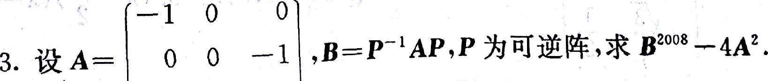

0 ' 1 0



174 ÅĘ Ø I¥ir -Ę:ßfi



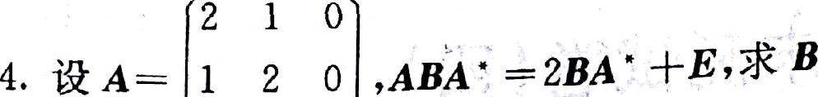 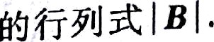

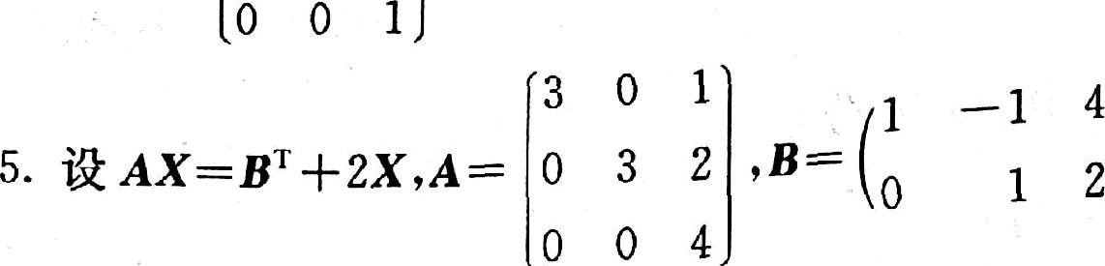 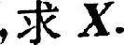

 



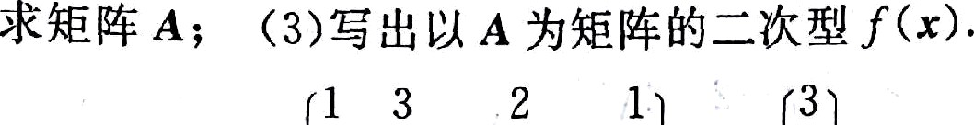

2. ì@ A , ò =

|  |  |  |  |
| --- | --- | --- | --- |
| 0 | 1 | 4 | 3 |
| 2 | 0 | 3 | 7 |

5









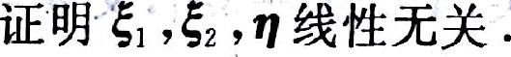



2

|  |  |  |  |
| --- | --- | --- | --- |
| 5 | 1 |  | — 3 |
| —, 1. 10 | 4. | 2 | 2 |

. —2 . 3.



IT oT 3 —2



2

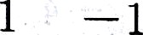

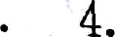

—

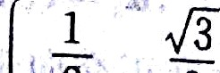

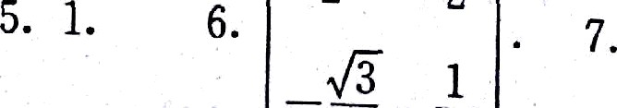

2 2

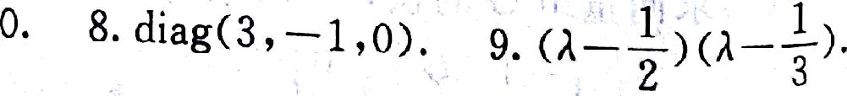





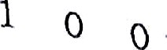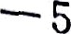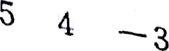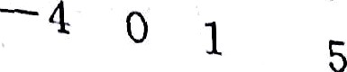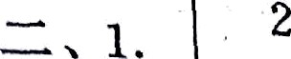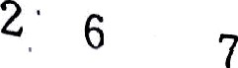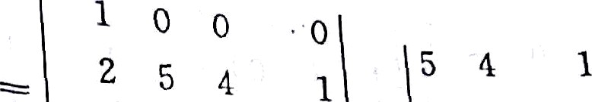

2

6

-3 -

2 6 —5

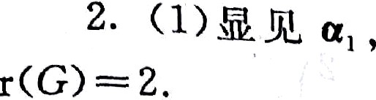

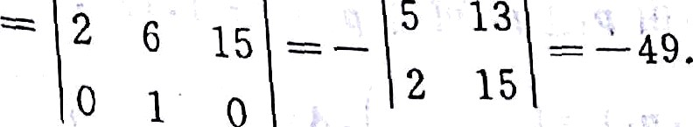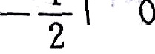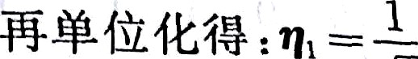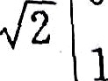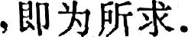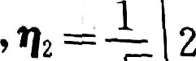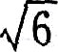

1 0 1 0

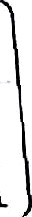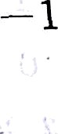





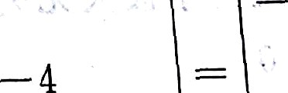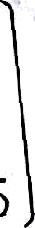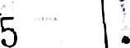

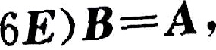

› II

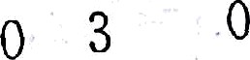

; o

0

0

0 ”!

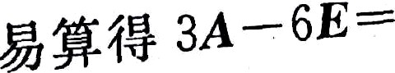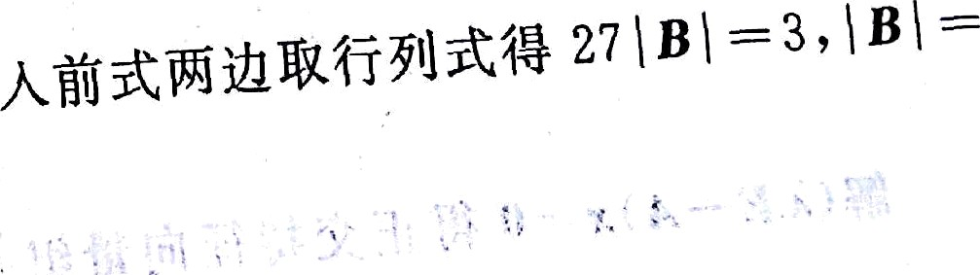

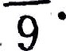 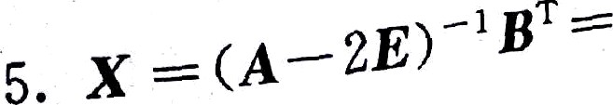

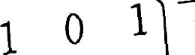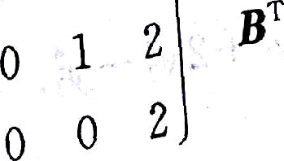



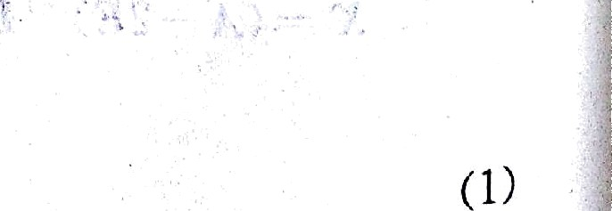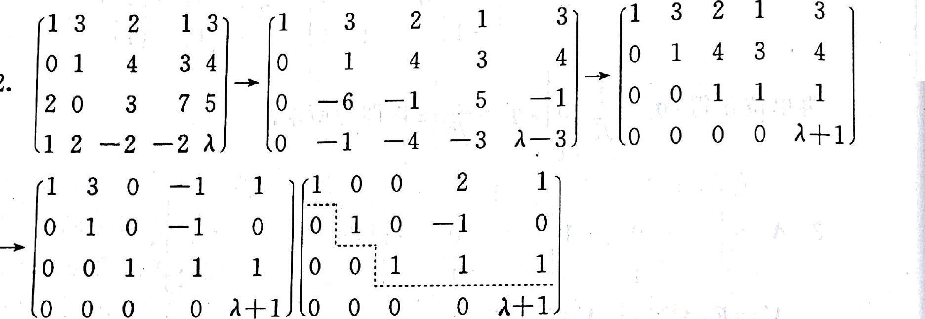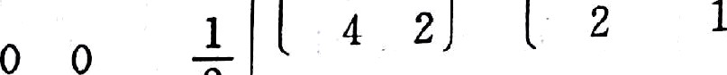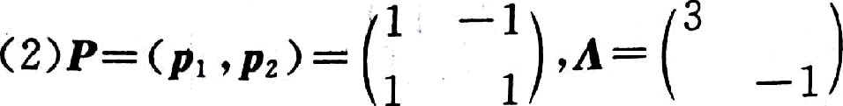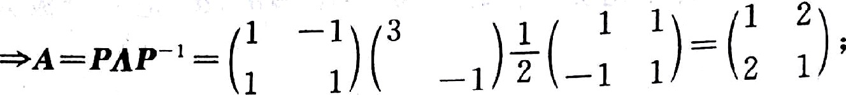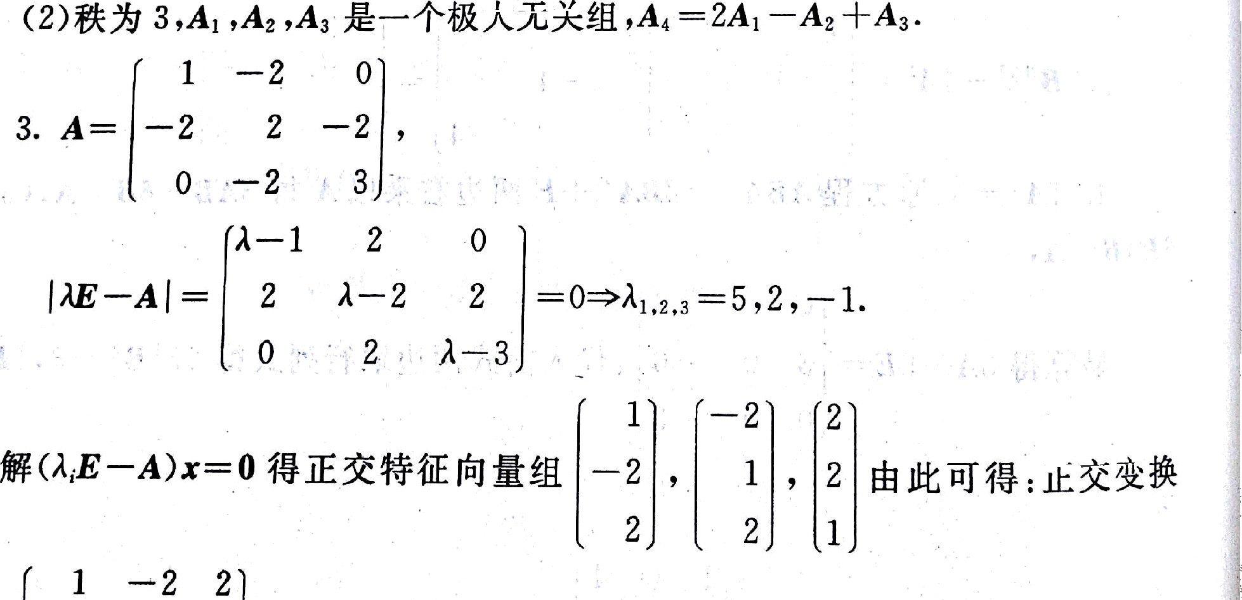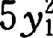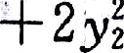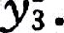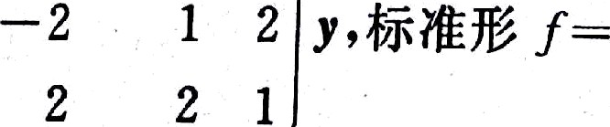

176



1 0



0 1 — 1 — 1 1 — 5 — 1

###### ‹ı› ı-— ı øïşf S.anź„ ‹-a‹—2, ı,—1 , )T+ ‹ı ,o, ı , , ;t Jt

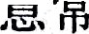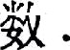

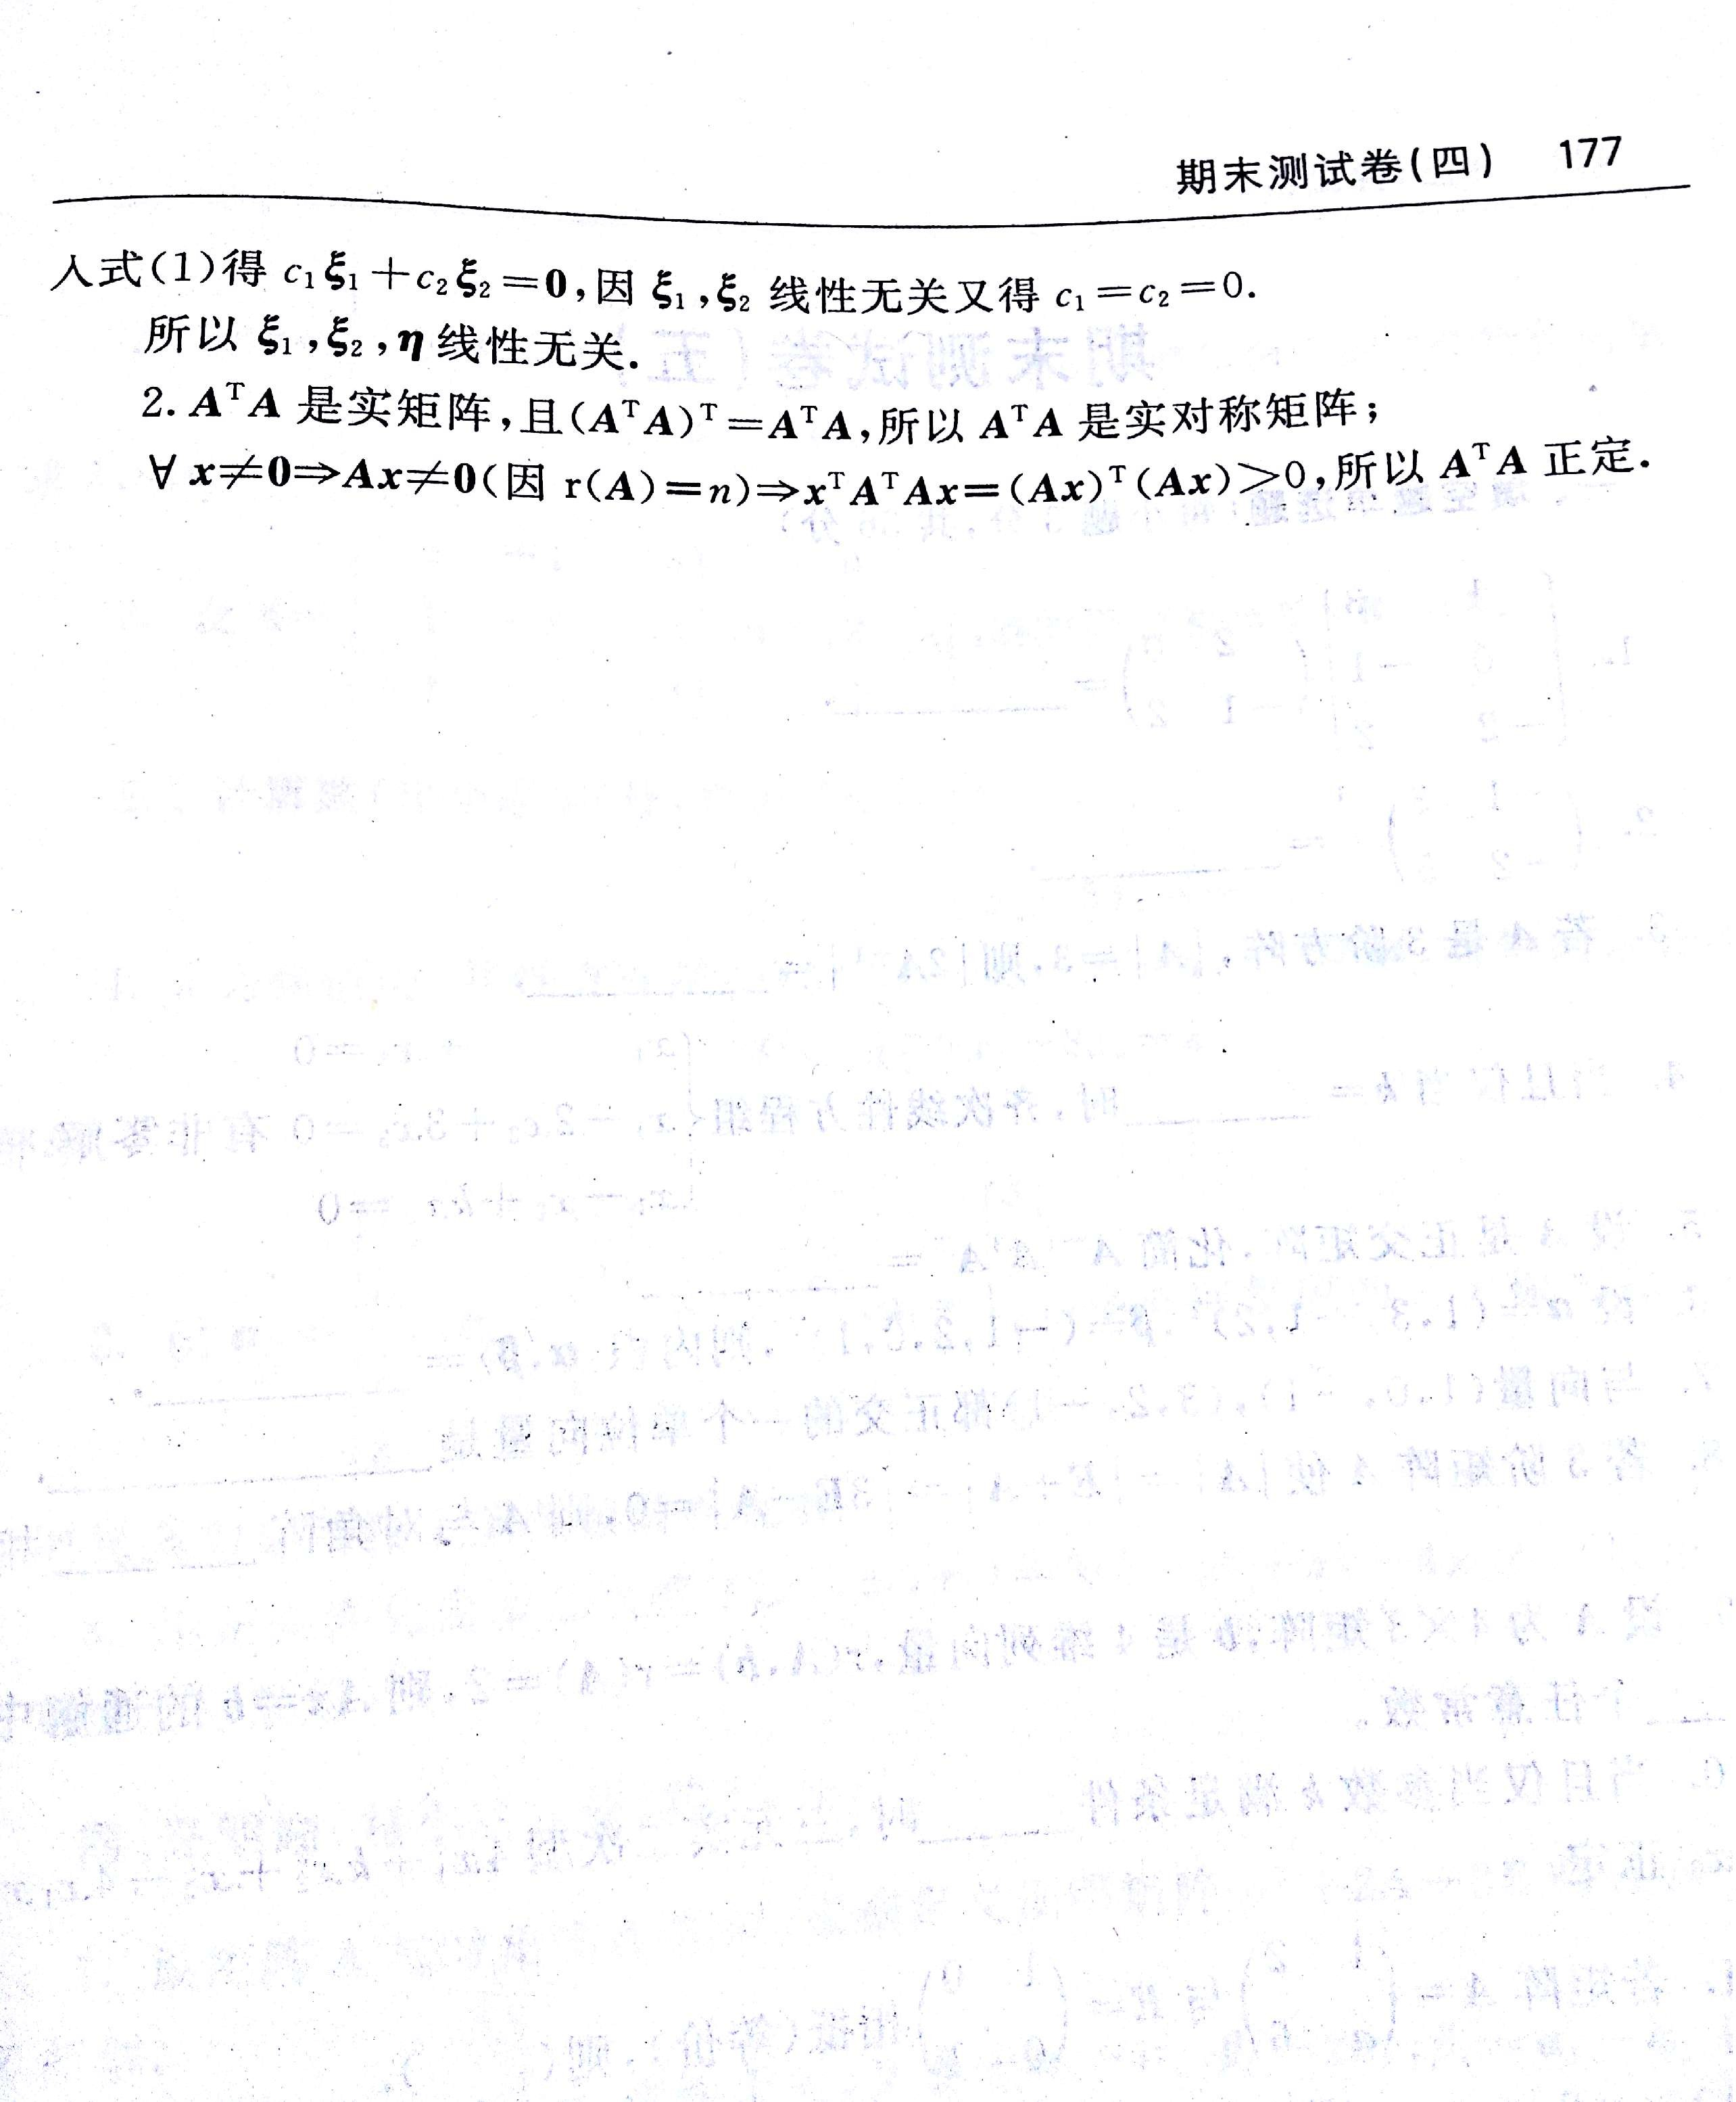

由 扫描全能王 扫描创建

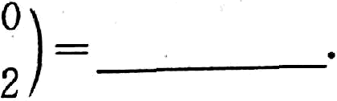

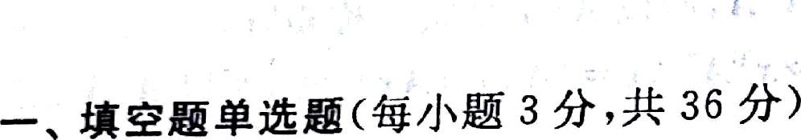

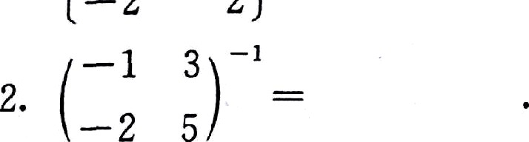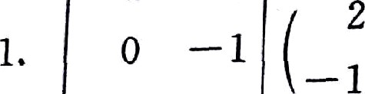

1

3

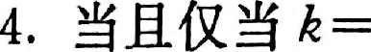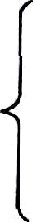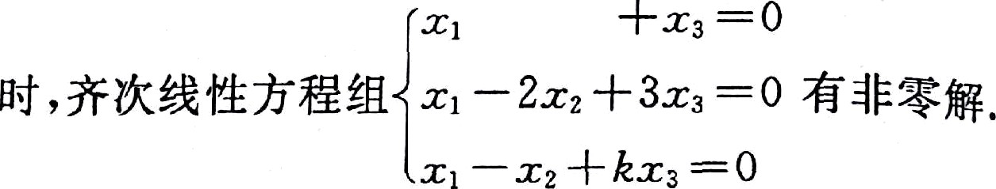

6. ì&°=‹1 .#•—*,2)T .ß—(— 1,2,O, g)T .*°!QÄ‹°,ß›=

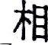



ı . Ź&ŒÈ9B è WA Âłł

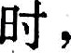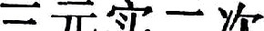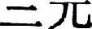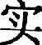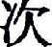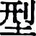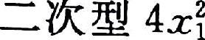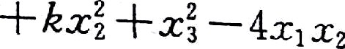

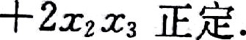





fA) 2 › 0 ; (B) 1,0 ¡

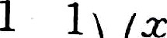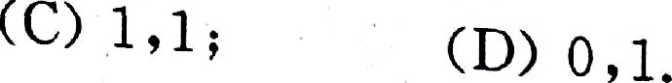

0 0

2 4 2

0 -2 S ç

3 İ 2



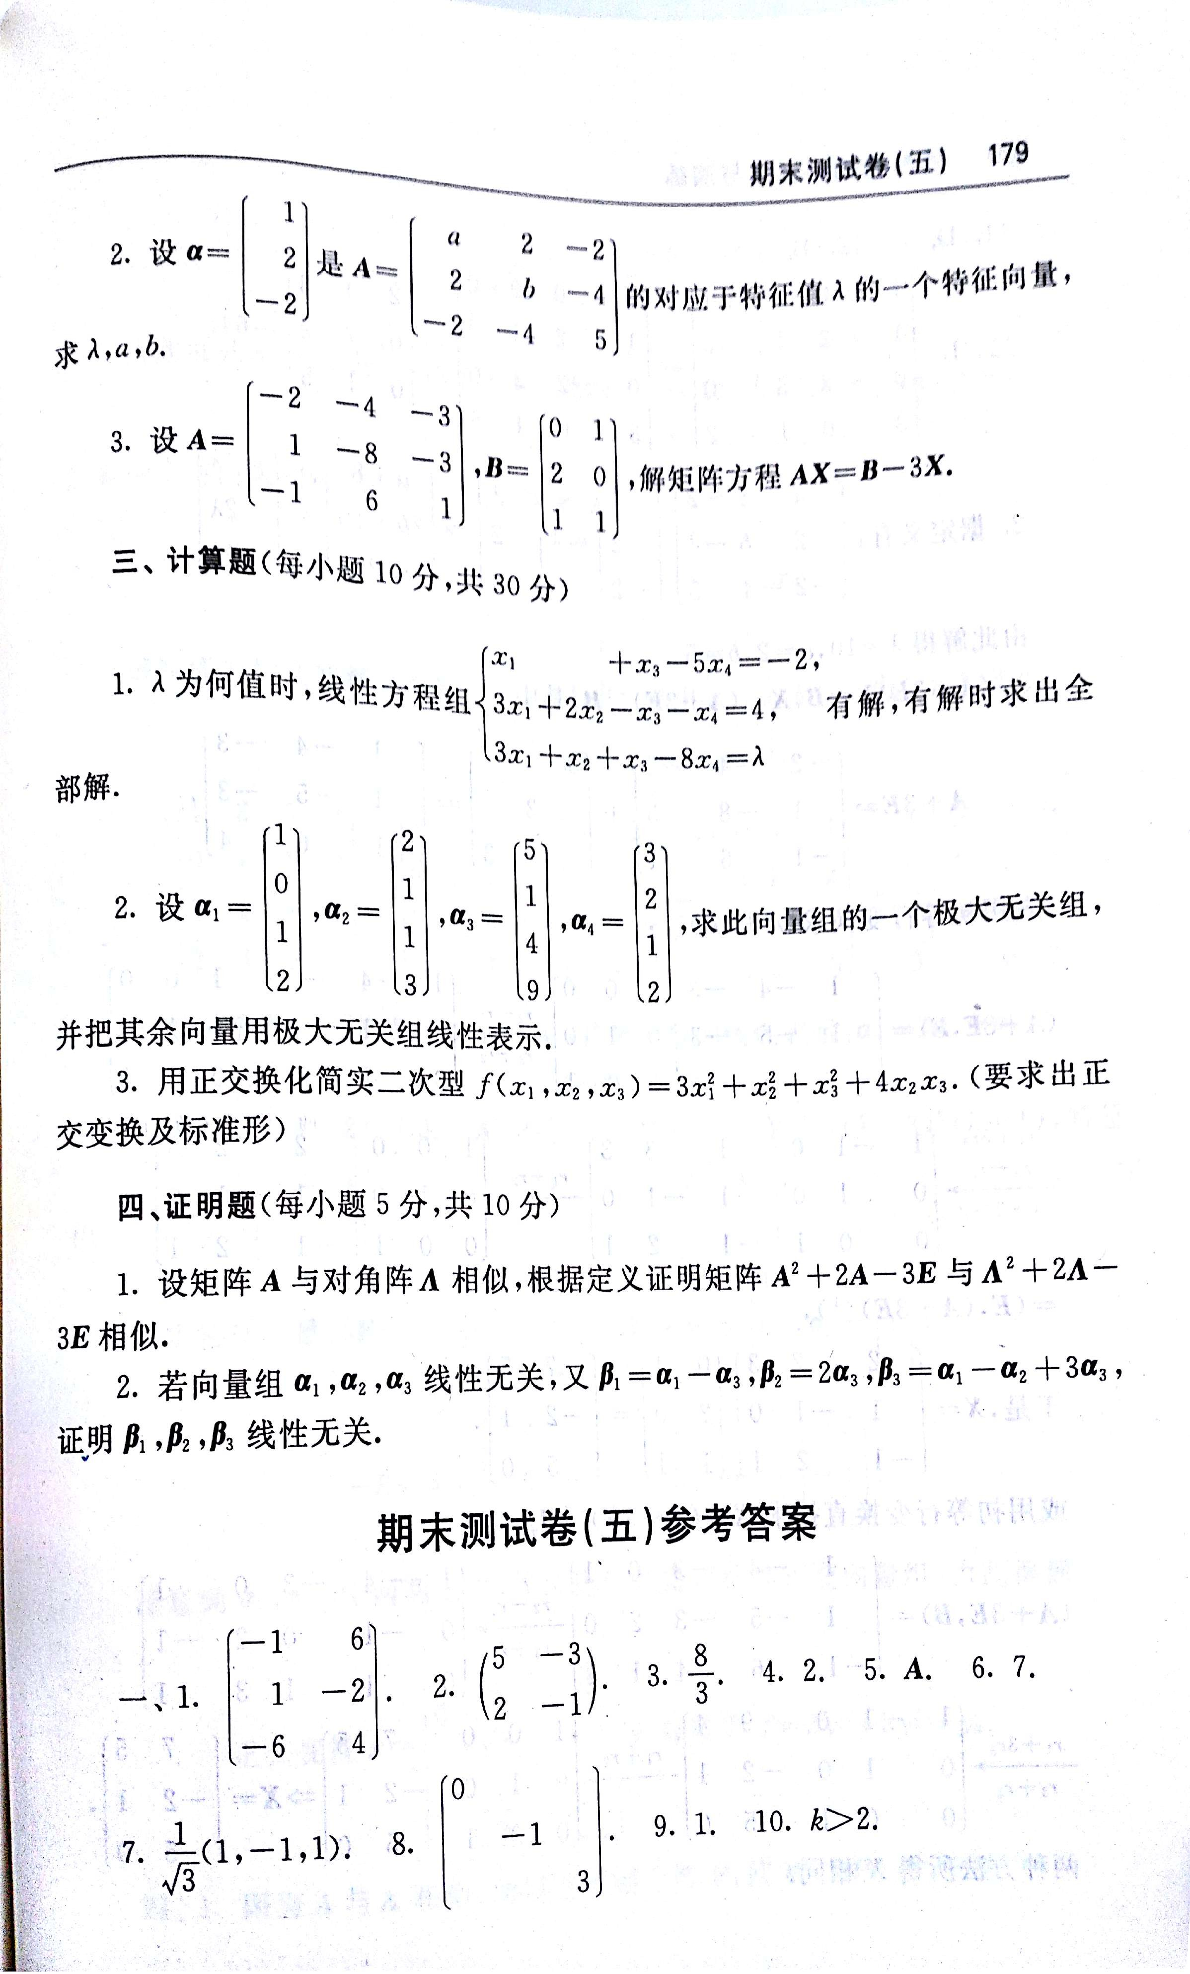

由 扫描全能王 扫描创建

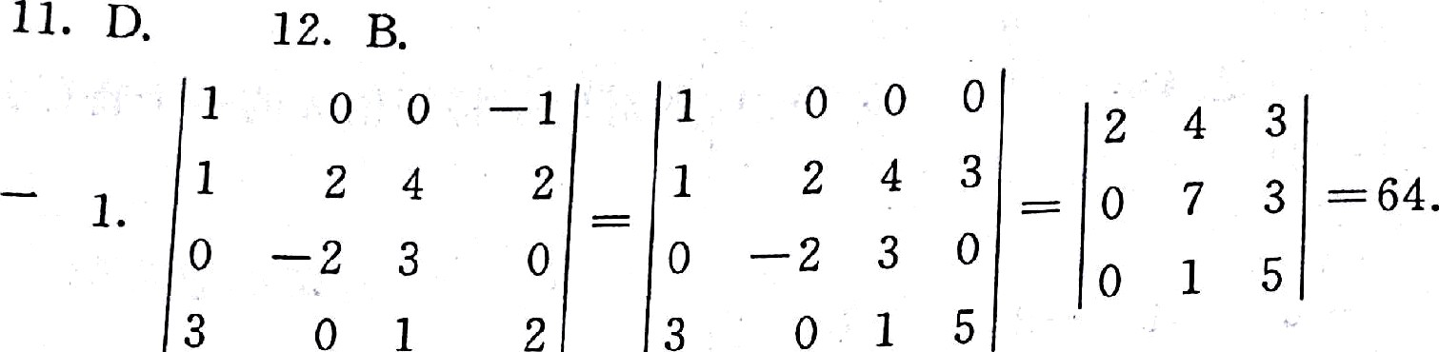

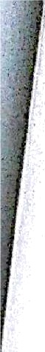

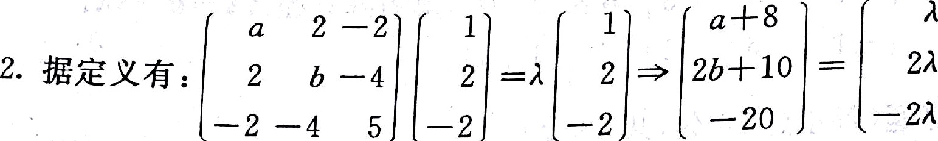

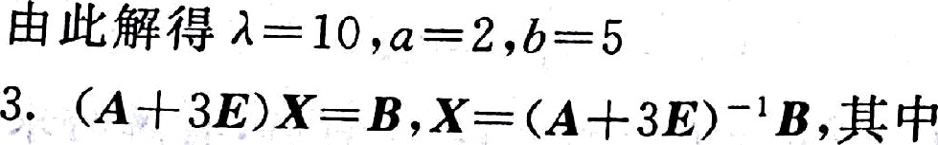

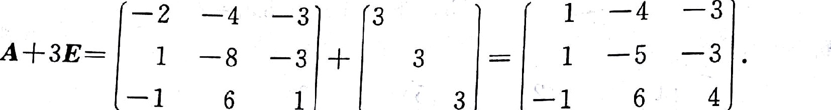



0 0 1 —4 —3 1 0 0

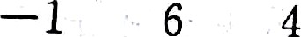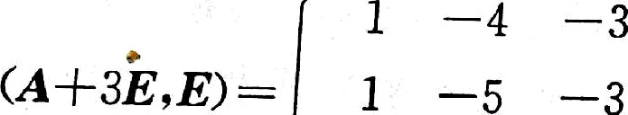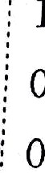

*2 *l

1 0 ~~-~~ 0 —l 0 ’—1 1 0

*r3 +* a

0 1 0 1 1 0 1 1

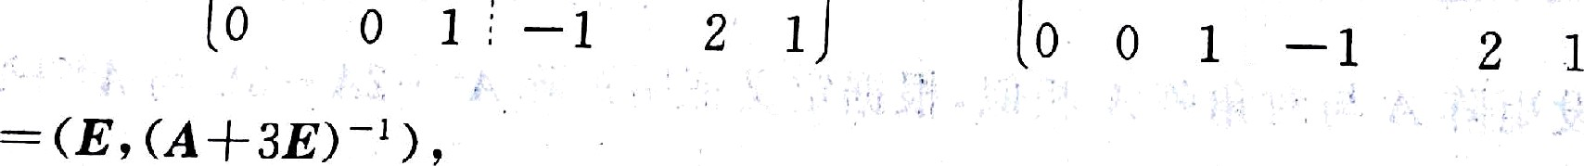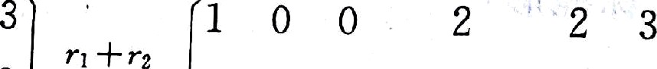

0

0 1 0

1

— ı

o

7&.x= ı —ı o z o —2 ¡ ,



— 1 2 ı 1 1 5 0

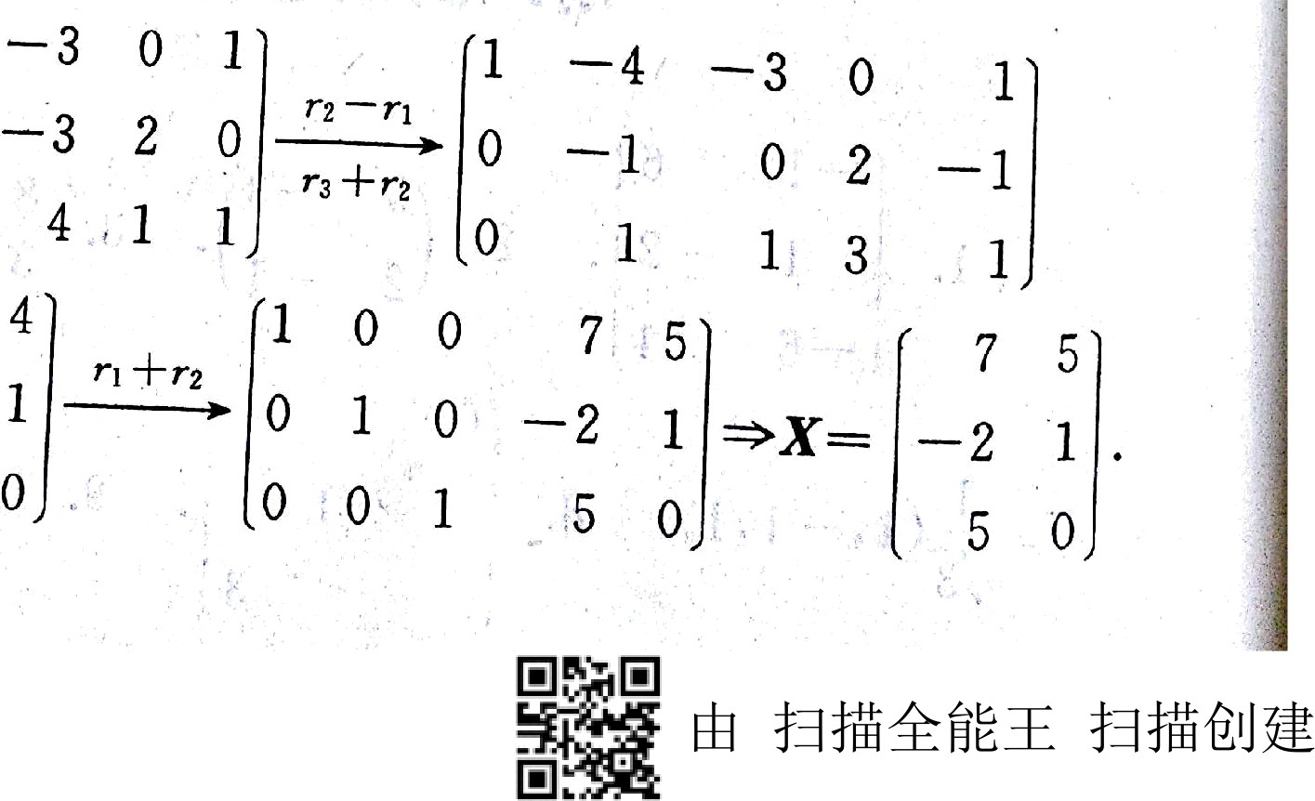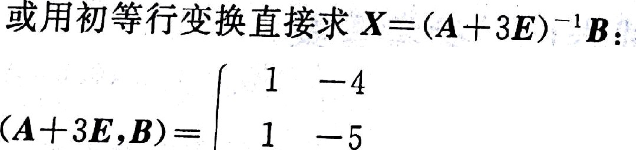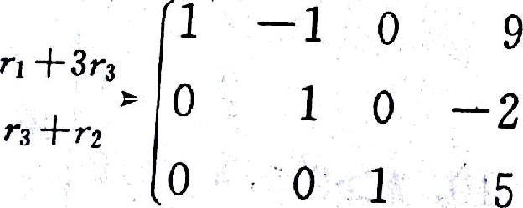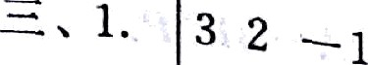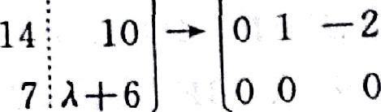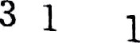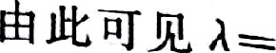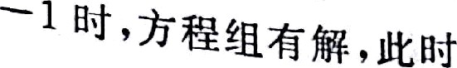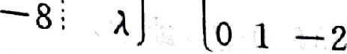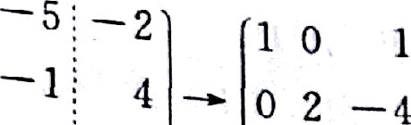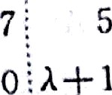

—5 —2

1 *

-ç: -2

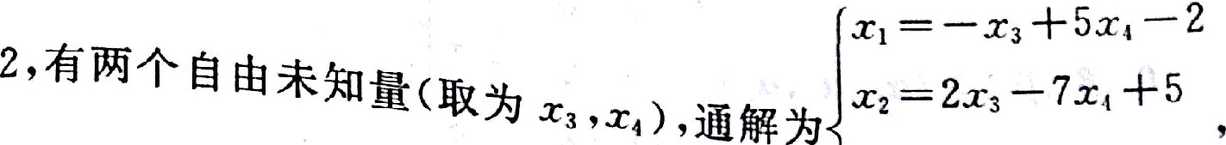

5 -2

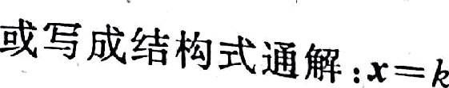 2 5 ,á, , ›, ńf2ã‹SØ-

l "' 0 + 0

0 ł 0

|  |  |  |  |  |  |  |  |  |
| --- | --- | --- | --- | --- | --- | --- | --- | --- |
| fi | 8 | l | 0 | S | —l | İ | 0 | Ã Ö |
| 1 | 2 | 0 | 1 | 1 | 2 | 0 | 1 | 1 0 |

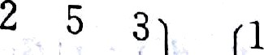

0

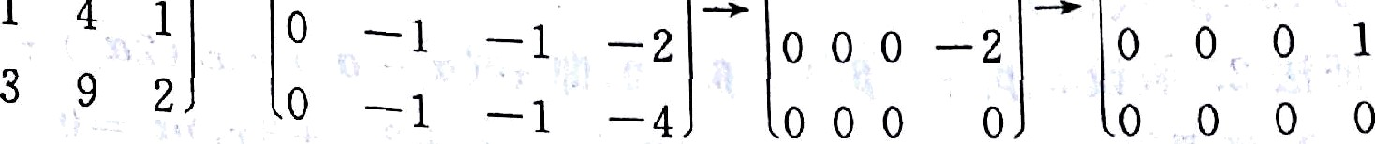

' ' '

j

2.



2

##### ‹— ı —2 = «— z›' «+», t¿¡E

|  |  |  |  |
| --- | --- | --- | --- |
| "' | 1 | # | ,)1—A |
|  | 2 | 1 |  |

—2 1— 1

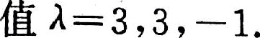

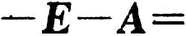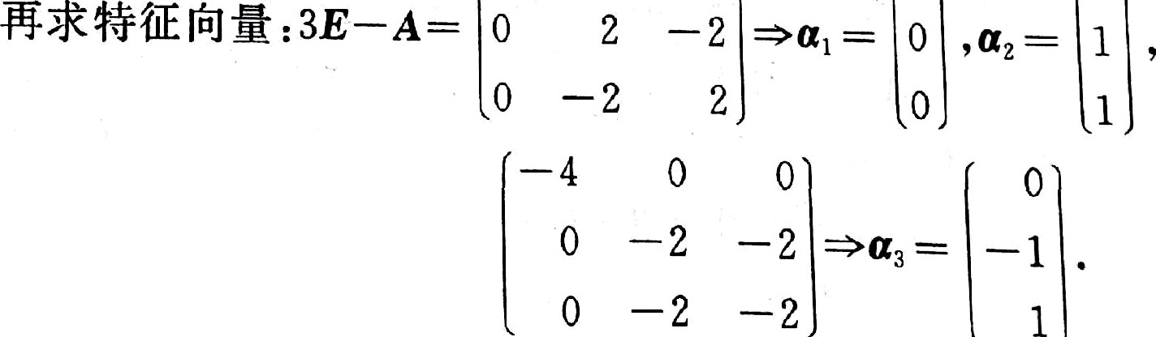

ß

0

0

1

0



0 ' 1

zxaa ‹= If •+' ›.łïss r— s›ì +sr, ,

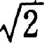

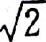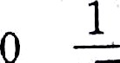





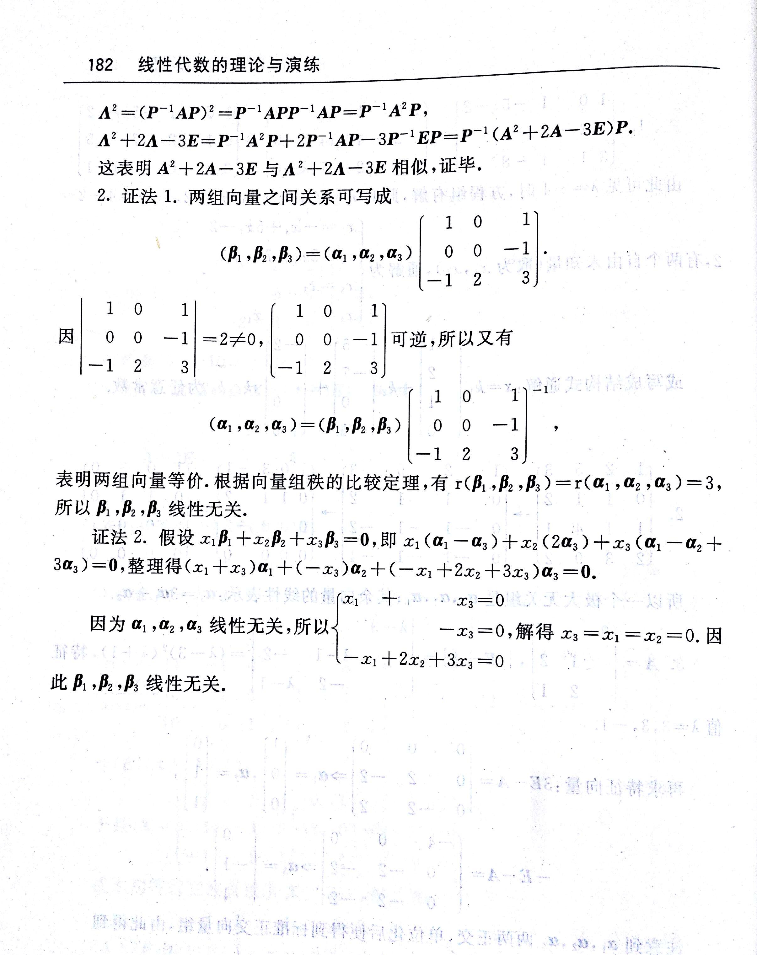

由 扫描全能王 扫描创建

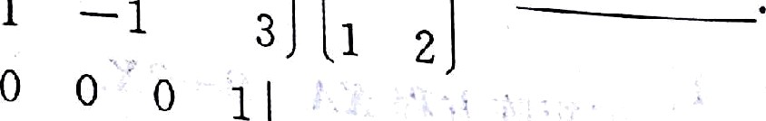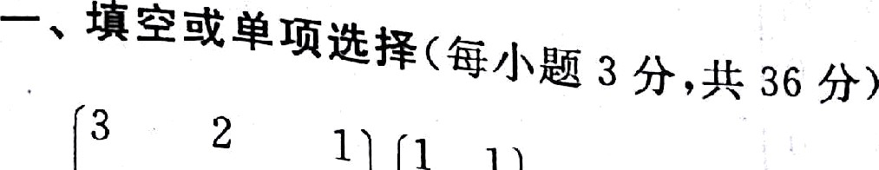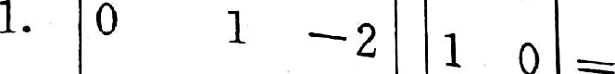

1 — 2 j

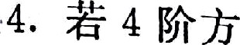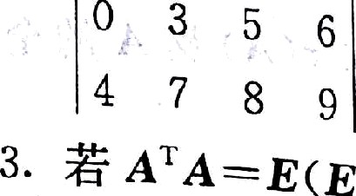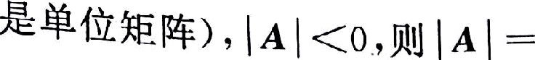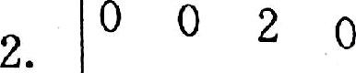

' " 2 ' ' * ãk&A& in&Öłt& * —

s. ' > '* żı s sí$ï Jx&. 214 ›t— z ,n+z , 2x — A ł#żć•% Œ .1*ś

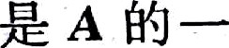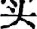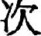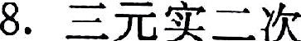

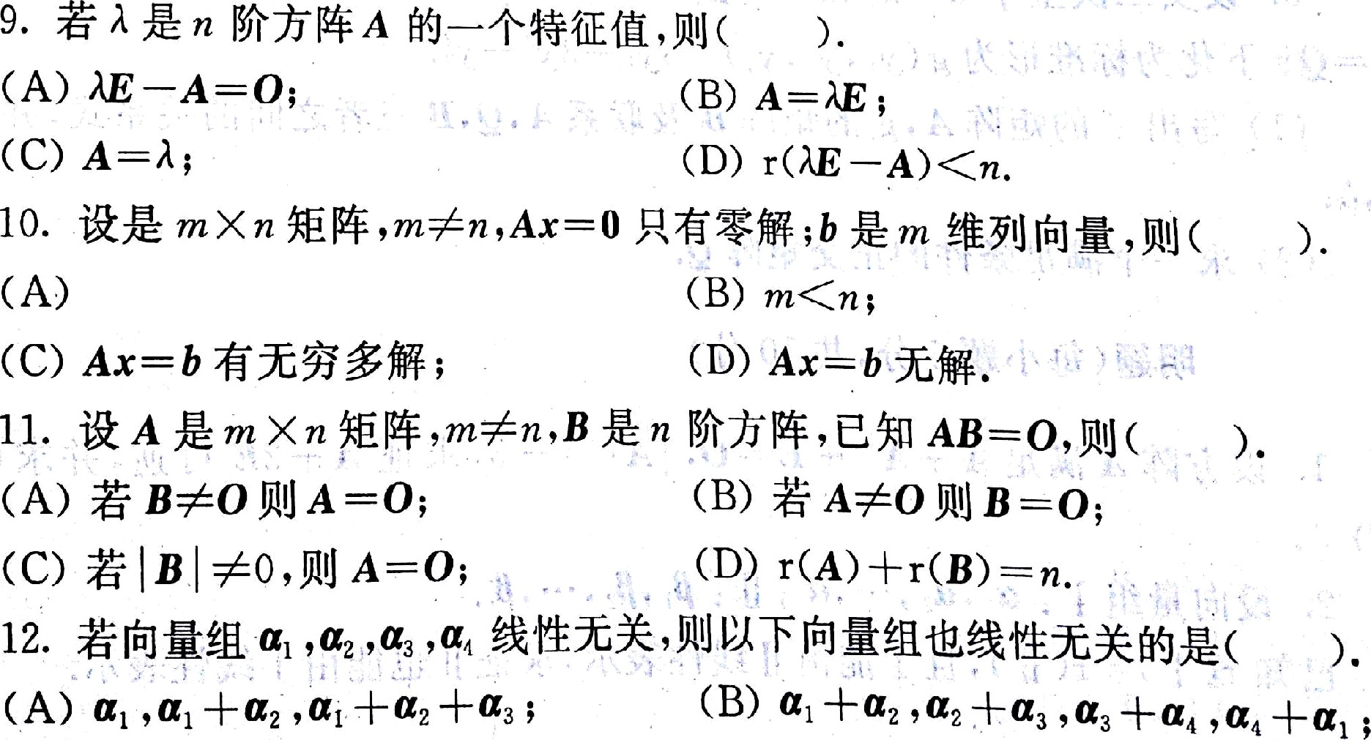

 



 

:::, it@śZ f«f /J*îII 8 6' " '

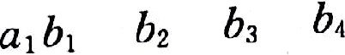

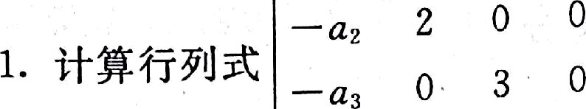

—‹, 0 0 4

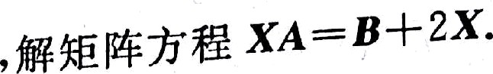

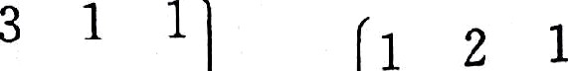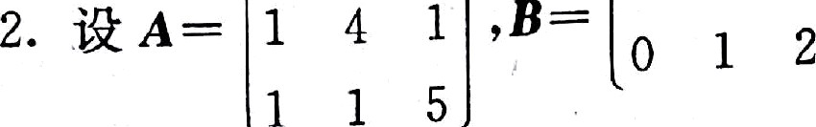



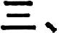 



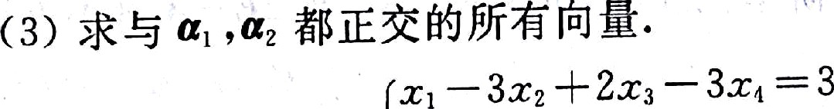



Õ .Õ i

‹to »9 3 *f BB łk 4 • g 8a8 B* ß& T.a .ß.ø ïı$:I:fa3 łûA f.»ï;. 4BS

###### ‹2s g ś•ãA& Jł & xŻØ& 0. & . iZøß m‹'ø›J'B s 9.ö ı 91

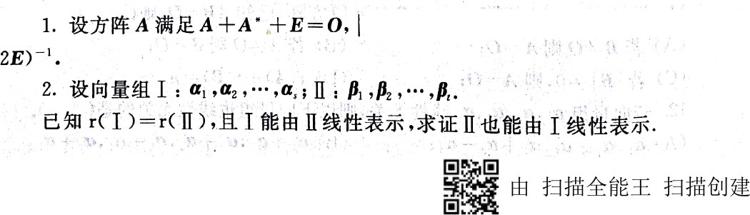

|  |  |  |  |
| --- | --- | --- | --- |
| 0 | 2 | 0 | 0 |
| 0 | 0 | 3 | 0 |
| 0 | 0 | 0 | 4 |

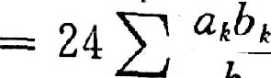



1 1 1 . 1 0 0 1 1 1 . 1 0 0

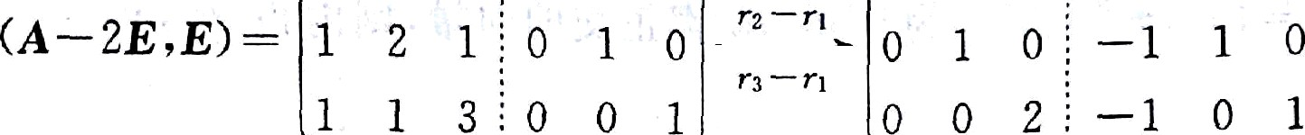

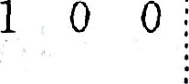 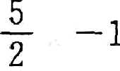

0 1 0 ; —1 1 0

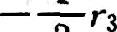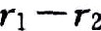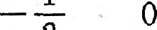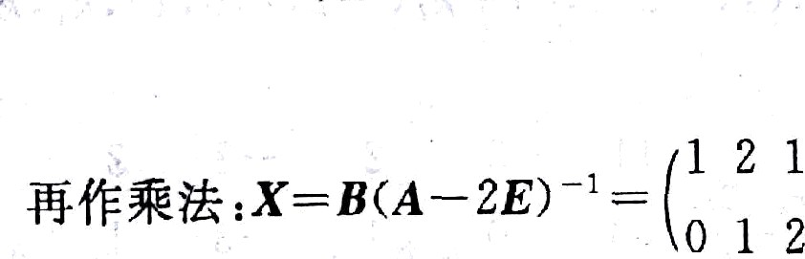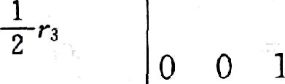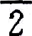

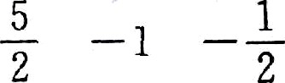

— 1 1 0 —

|  |  |  |
| --- | --- | --- |
| 0 | 1 | 0 |
| — 2 | 1 | 1 |

1 ı

— 0

— —

2 2

1 I ı 1 0 o

121 110

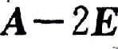

= 11 3 ~~"~~ 1 0 2

*B*



10 0

ı o ı o

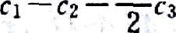

ı 0 0 1

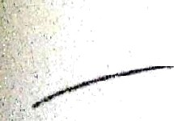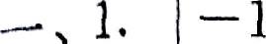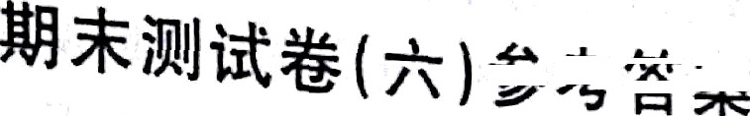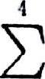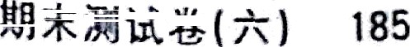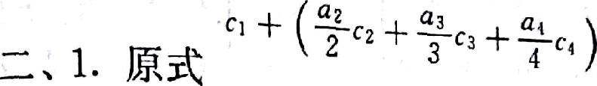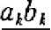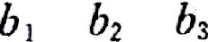

6

s

0 1 2 0 1 2 — 2 1 1







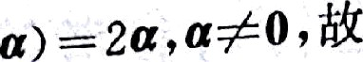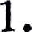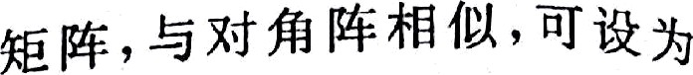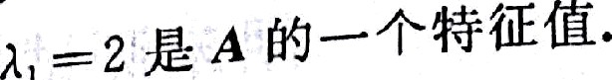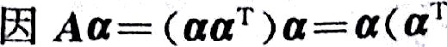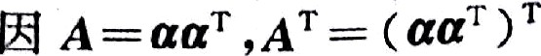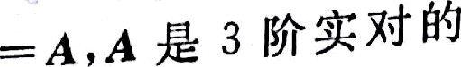

*8* gpğpø¿j¡şø y , o , o.

|  |  |  |
| --- | --- | --- |
| 0 | 1 | 2 |
| 0 | 0 | à +2 |
| 0 | 0 | 0 |

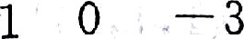

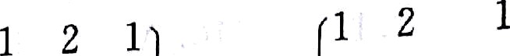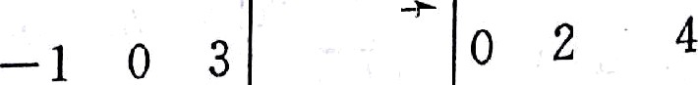

2 2 A 0 2 A+6

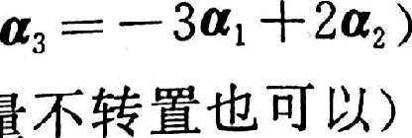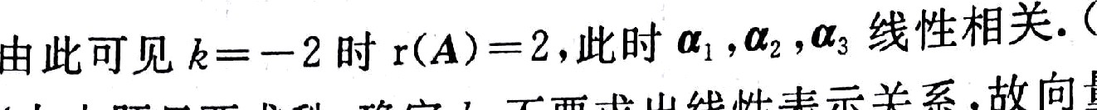



fı =12, 1,0, 2) —

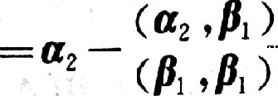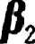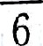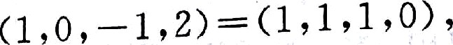

6

øïíä $ .$› -$Üäï8 :r› -,p¡ ı ,0, —ı .to '*'

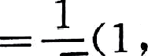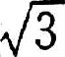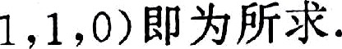



10 —12 10 —1

21 0 2 01 2

2æ,

2ı,

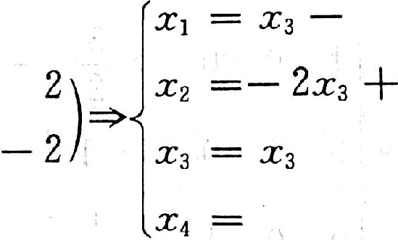

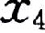



R.

|  |  |  |  |  |  |  |  |  |
| --- | --- | --- | --- | --- | --- | --- | --- | --- |
|  | 1 | —s | 2 | —3 | s | 1 | —5 | 2 |
| 2. *(A› B)* | 2 | —6 | 5 | —9 | 7 |  |  |  |
|  | 3 | — 9 | 4 | *a* | *b* | 0 | 0 | — 2 |

—3 g

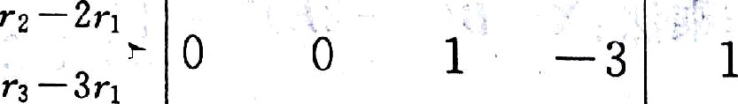

a-ł-9 *b— 9*

/ — 3 0 3 1

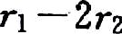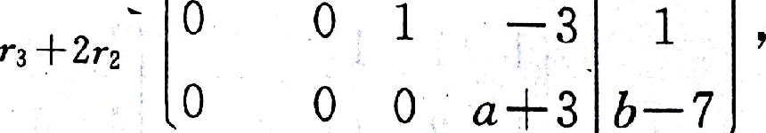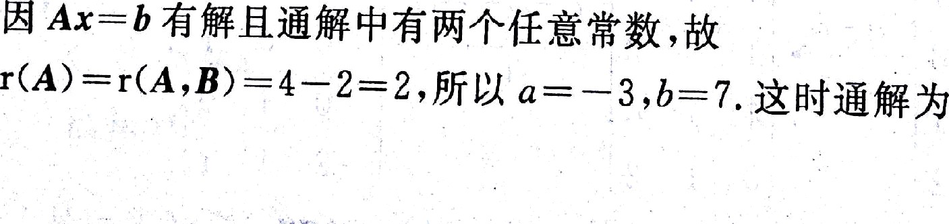

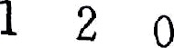

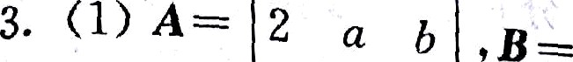

0 ò j

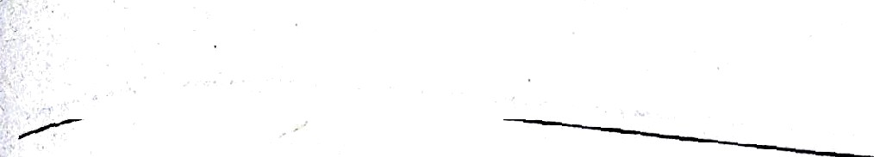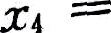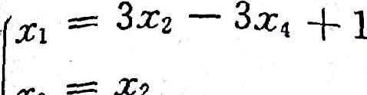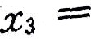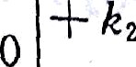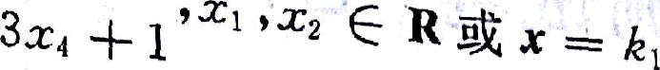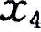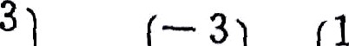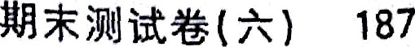

0

0

R.

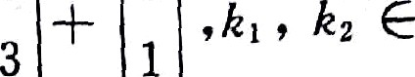

0 1 o

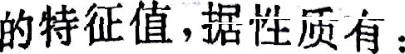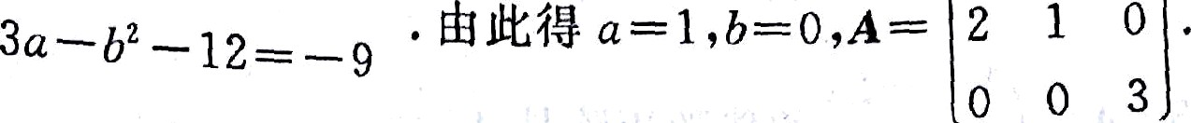

2

—2 o

î — ï 0

o

!

0 0

O

O 0

}

0

|  |  |  |  |  |  |  |  |
| --- | --- | --- | --- | --- | --- | --- | --- |
|  | -2 | 0 | 1 | 1 | 0 |  | -1 |
| ""” | — -2 | 0 | -• 0 | 0 | 1 | »s3= | 1. |
|  | ö 0 | -4 | 0 | 0 | 0 |  | D |

**ÄlÄÃÄ*â Ä ÜÄÍVÍŻÄÄÄfÓÍ#iÓÄiB ÀÃ İ**

0 —1 — 1

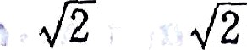

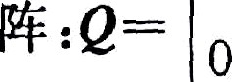 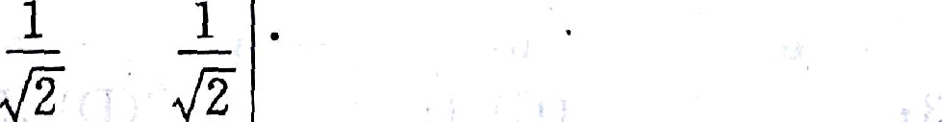

l 0 0

æ. ı. *+›ı-* +z-o&azisr a ;$a2 —sx+a=o, û=ø

*‹ +txt* ‹a—‹)=a'+a— ız=a'+a— sx+z=z,

2. łJáØ% .%îit rt I) —r( 0 I=••°., . '.°.,& 1 & ś“Ø~~ź <ść~~iłl .hì lìlł

r(#„,”’›#„ ) r( )'<›

### #°.› °...



„

›s.



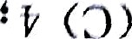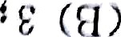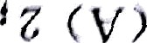

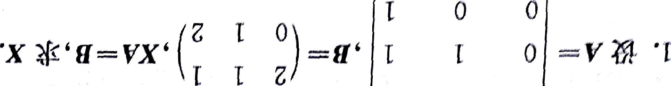

(ù 0:-ıf'Cï 9 vw‹J'l *4*)N#Rfłł '

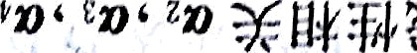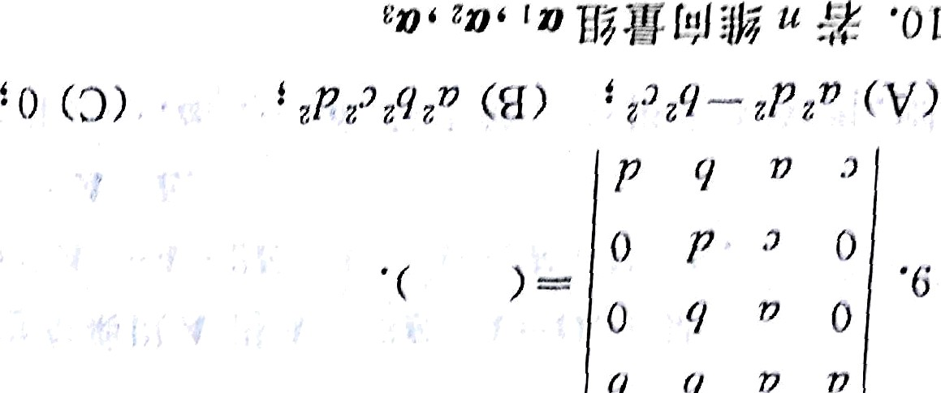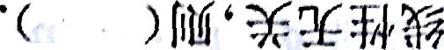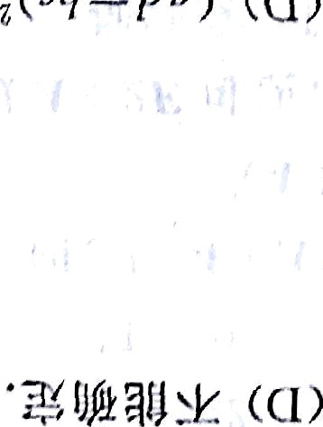



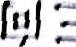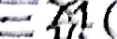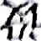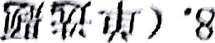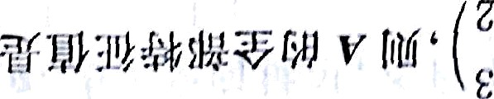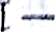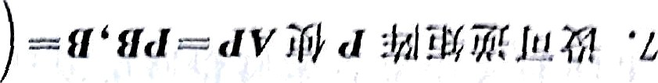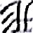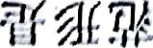



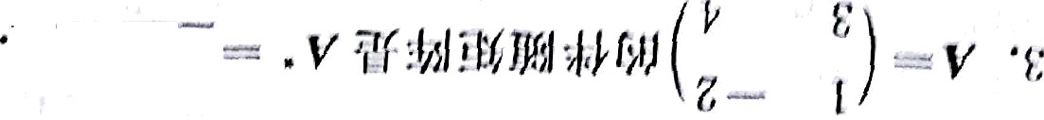

, *I vz )* - ı v£ I htm -¿ = I VI ù'łı/? Î ’ :ïïl:'ł/‹ł*ił łi ;'/ *v* ¿,j '¿

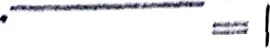





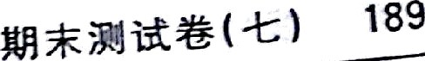

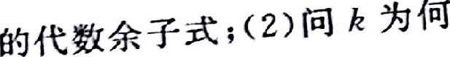

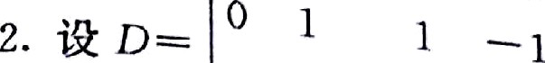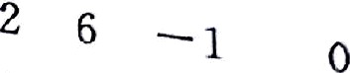

@B¿ , *D* -0.

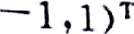

' ' 1 o

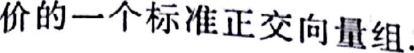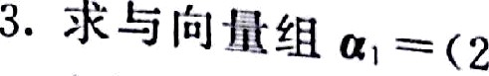

,0,



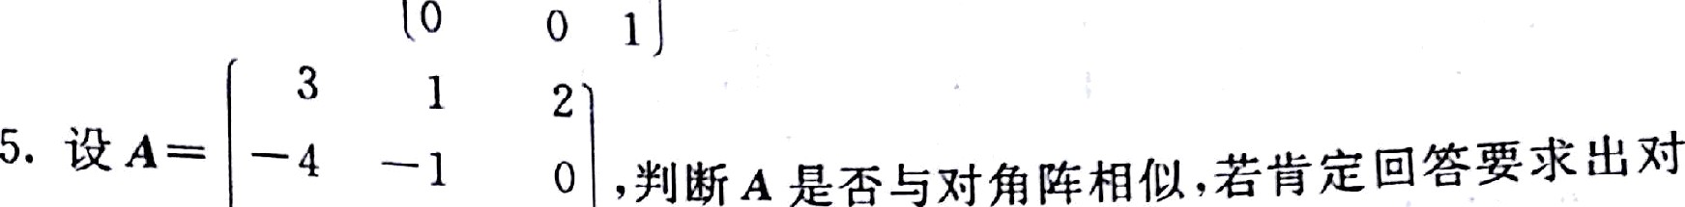

Ö 0 -2

 



0 1 2



1 1 0 —3 -2

'3 ’°''—› '°" ‹ ’ °' ' › t '° “ s

1 2 — 1 0

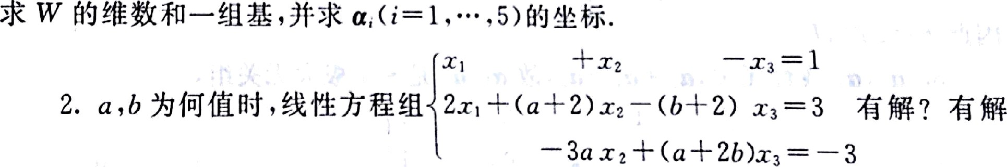

z 1 0 2



*z. uB ›ı=* ı o —h a= › zmæ‹›a .:t •,› st z,«›sø q ,

0 0 2 — 1

TAp- II.







*no* & 'ìt €f£ ıtśıäiß—'ż :*ã



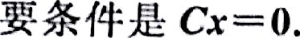

—27

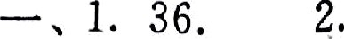

4’

3. 4 4. 6.

—3 I

|  |  |  |  |
| --- | --- | --- | --- |
| 5. | 1 , 5.  10. | Ć. |  |
|  | 2 | 3 | 0 |
| " | 0 | 1 | 1 |

9. D.

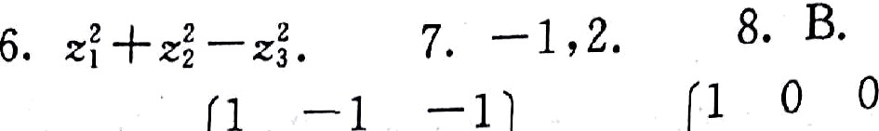



~~””~~ 0 0 1 ,Z “

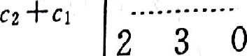



|  |  |  |  |  |  |  |
| --- | --- | --- | --- | --- | --- | --- |
| 0 | 1 | 2 |  | 0 | ł | T |
|  | 2 | — 1 | 0 |  |  |  |

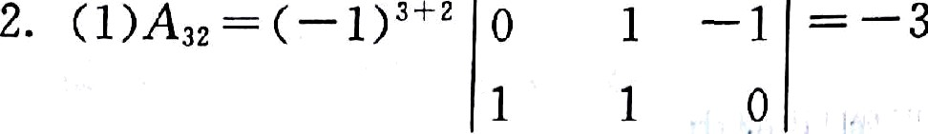

2 6 —1 0 2 0 -l 0

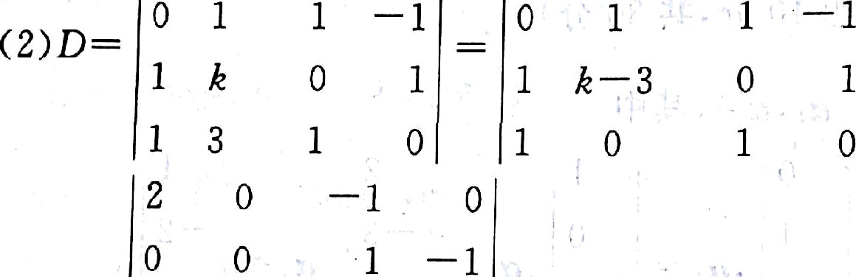

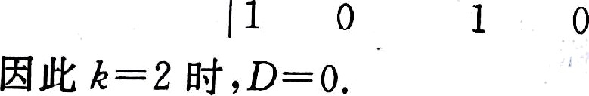

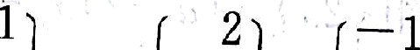

1 g 0 ı

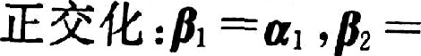

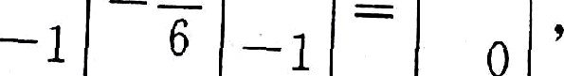

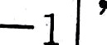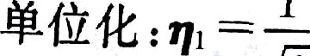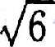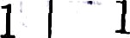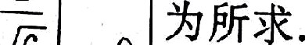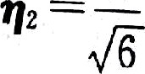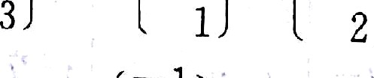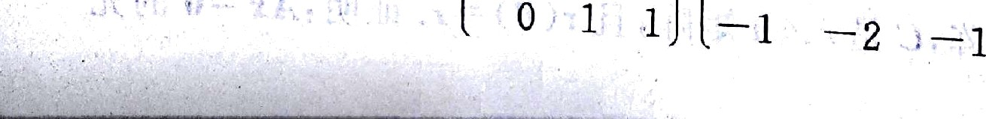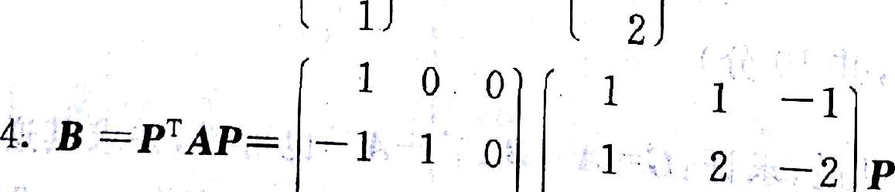



& ¥äJi&6 ( ) 191

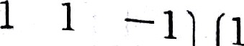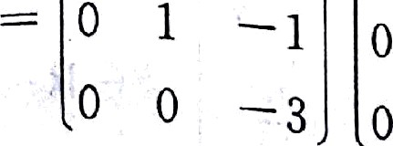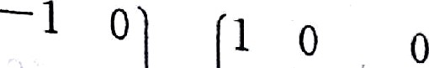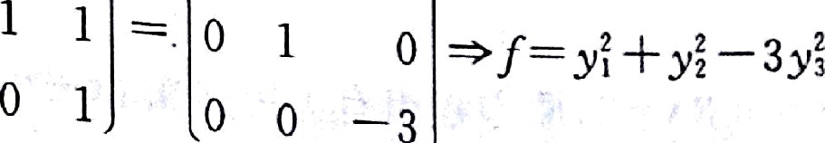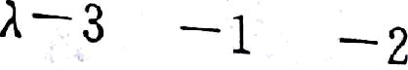

' ' ' o = or+to ‹ı— ı)',ı -ı,ı, —2 ı+ı

o o

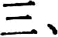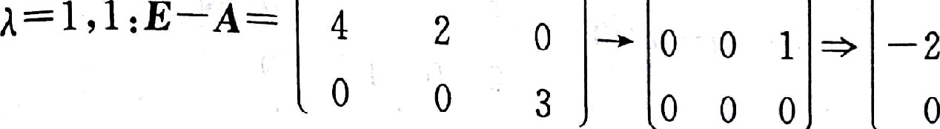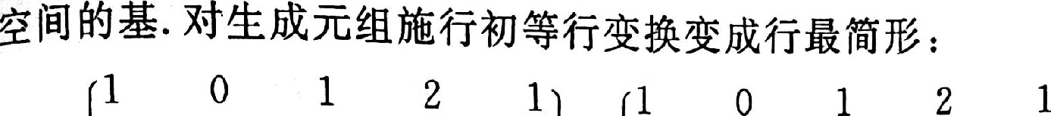

|  |  |  |  |  |  |  |  |  |  |
| --- | --- | --- | --- | --- | --- | --- | --- | --- | --- |
| 1 | 1 | 0 | — ä | —2 | 0 | 1 | — 1 | — 5 | —3 |
| 3 | —1 | 1 | ï1 | 6 | 0 | —1 | 1 | 5 | 3 |
| 1 | 2 | —1 | 0 | 3 | 0 | 2 | —2 | —2 | 2 |

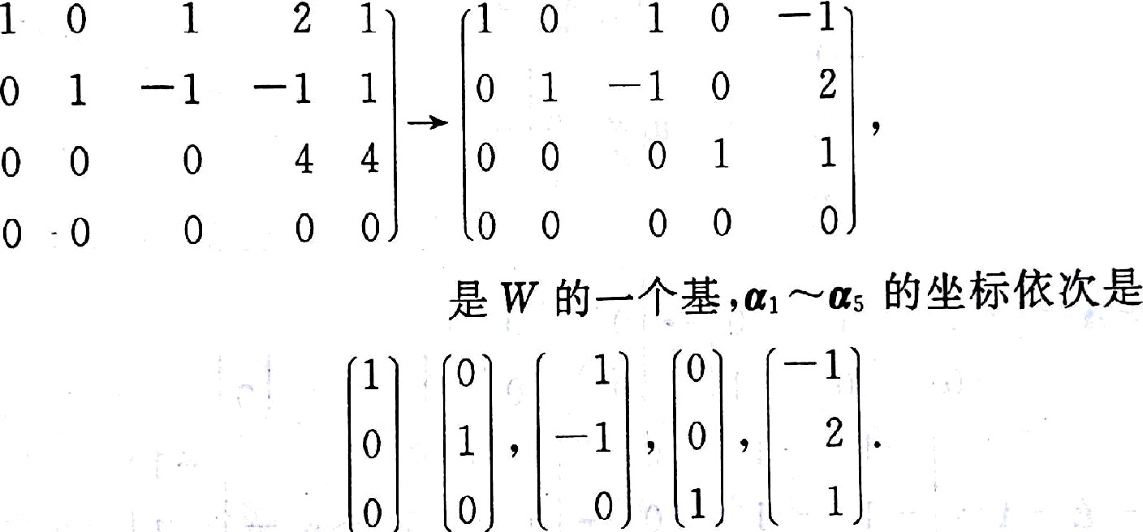





ı ı

|  |  |  |  |  |  |  |  |
| --- | --- | --- | --- | --- | --- | --- | --- |
| —ı  *—b* | ı  1 | ——• | ı  0 | ı  0 | —ı  *b* | ı  0 , r(A)<r(B) › IİİÏJ | NÑi |
| *— b* | 0 |  | 0 | 0 | 0 | 1 |  |

s=o aì,›ı, — 0

0

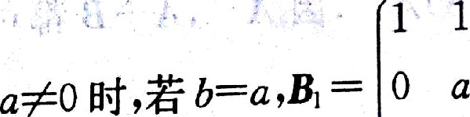

0 0

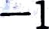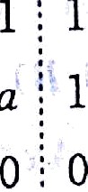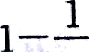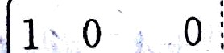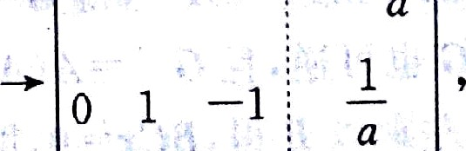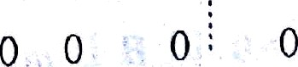



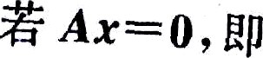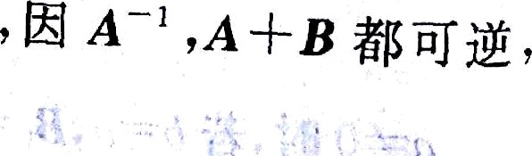

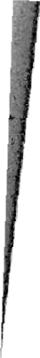

0

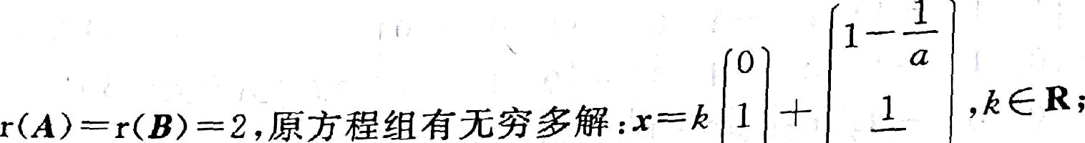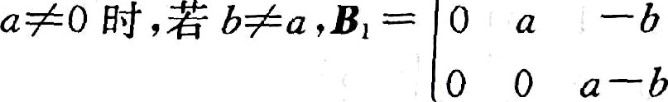

1 1 -1

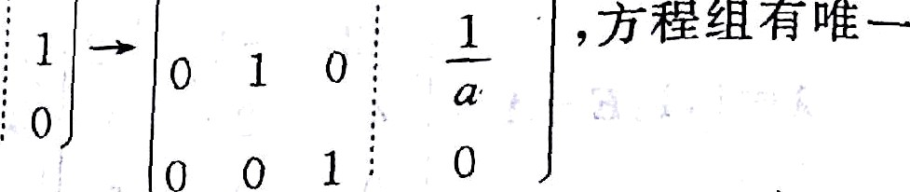

.1

1 0 0 . / -

°

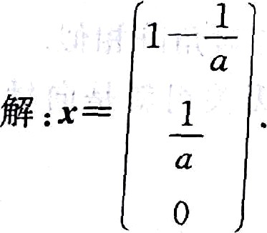

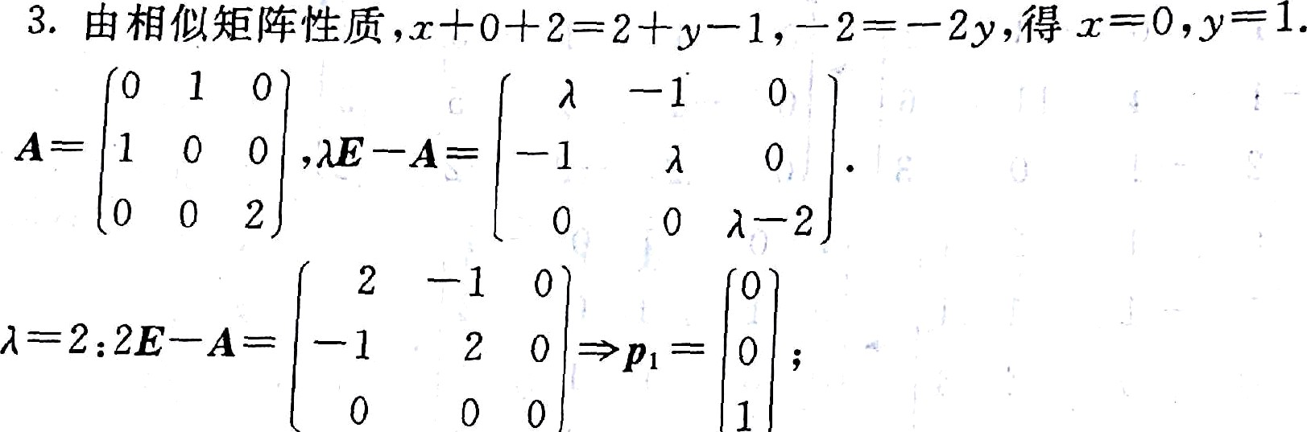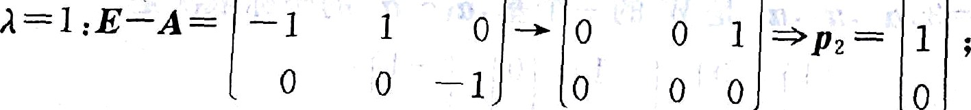

1

0

I — 1

o

ı



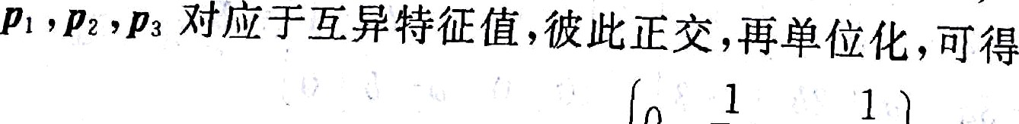

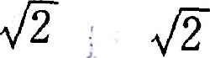



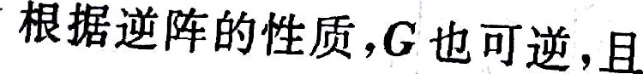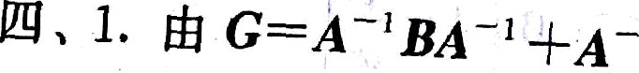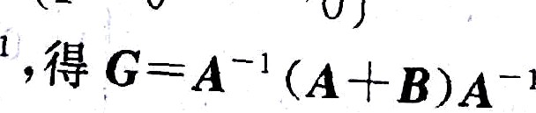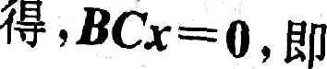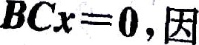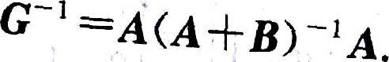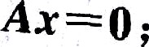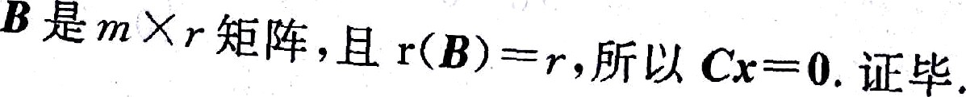

*

a c*—0,¿¿g ry ø '